July 20th 2024

This document details cosmetic and mechanical problems with
the home located at 1036 Logan Road. It’s purpose is to assist in
determining fair market value of the home

Parcel ID: 0751-F-001170-0000-00
Owner Name: Brian McKay
Municipally: North Versailles
School District: East Allegheny
Year(s): 2024

Home information
Make/Model of home: 1992 SKYLINE Mobile/Manufacturing Home
Pennsylvania Certificate of Title Number: 44391156
Home VIN: 46390123EAB

EXTERIOR
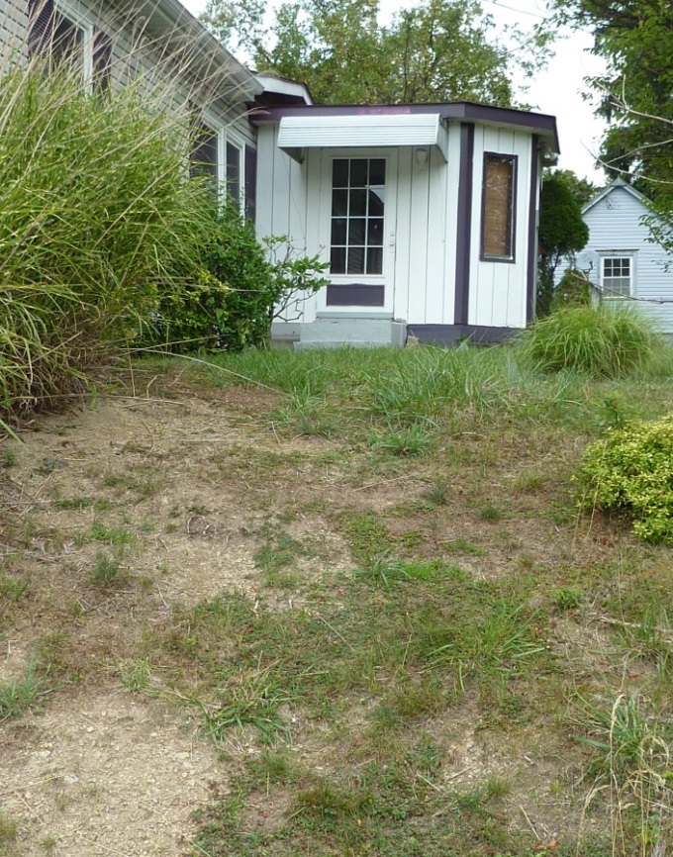
- No sidewalk or lamp post to the entrance foyer.

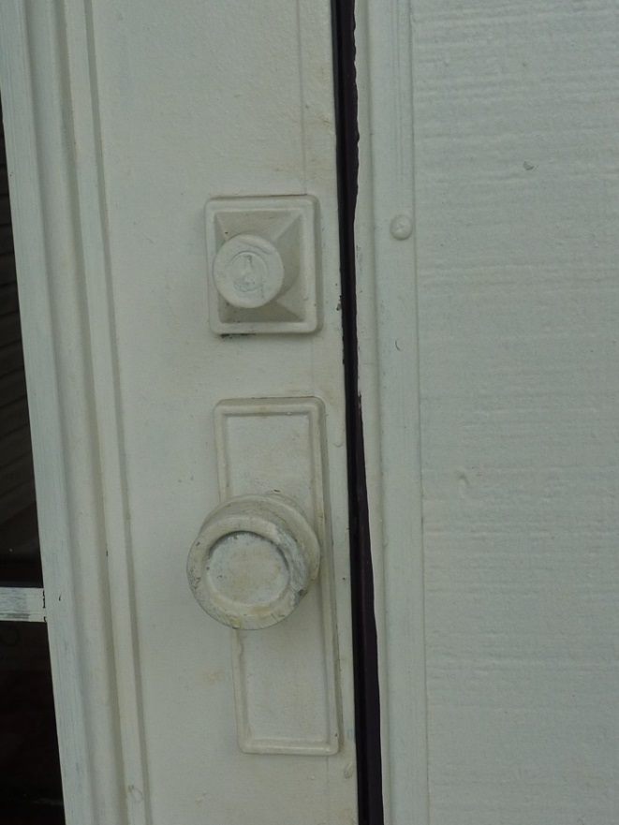

- Foyer exterior storm door lock is painted over and plugged. The doorbell button is missing.
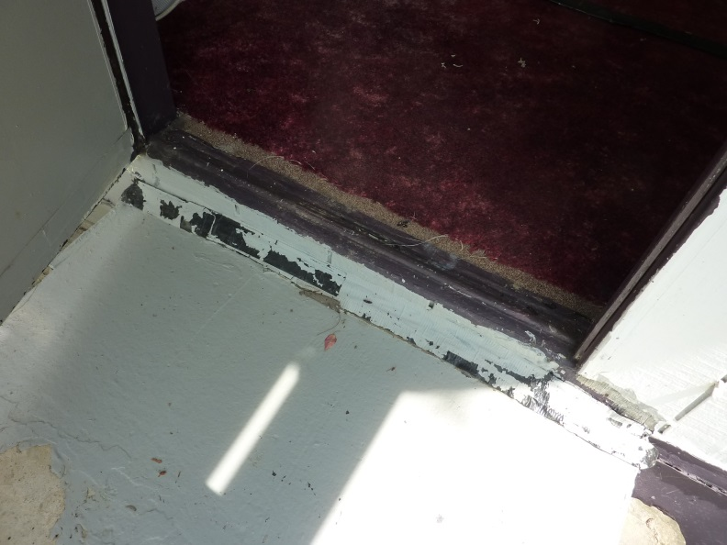
- Foyer storm door threshold is duct taped and painted over.

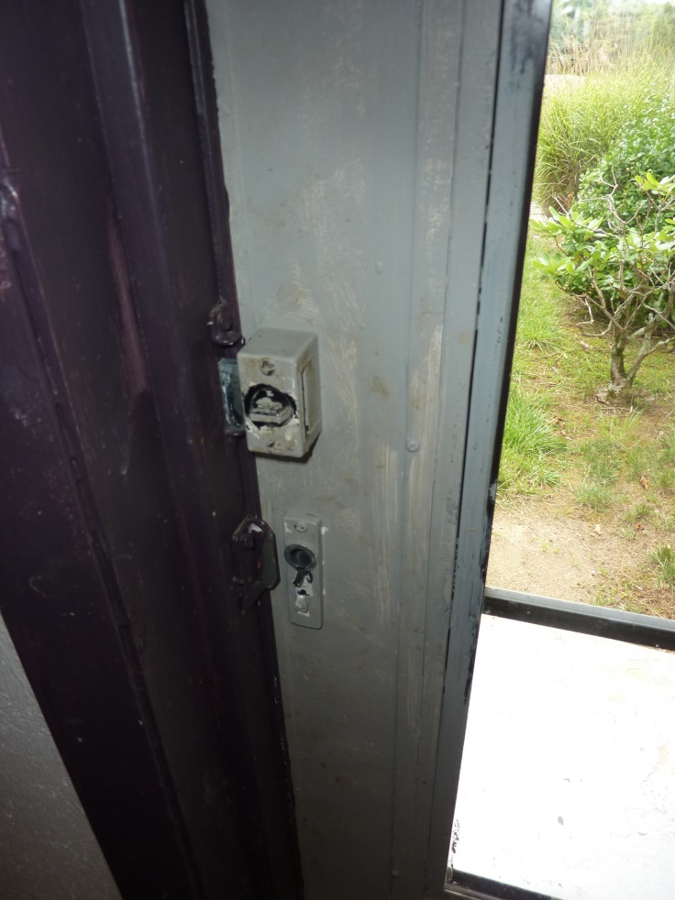
- Foyer inside storm door is missing its handle.

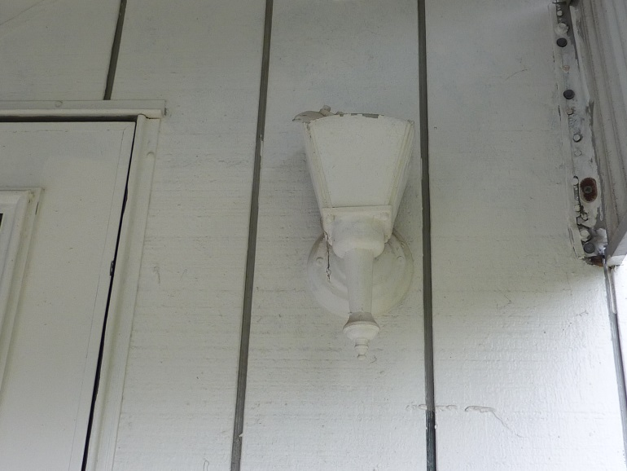
5. Broken foyer entrance light, the top is missing and painted over multiple times. Does not work.
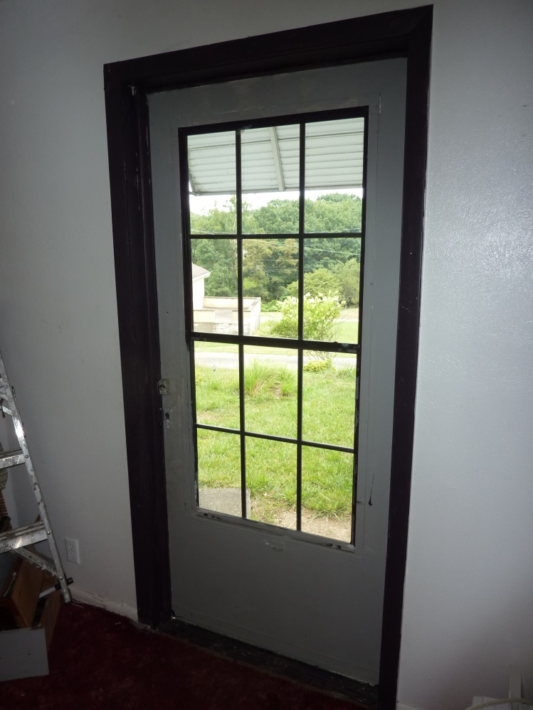
- Foyer interior door missing.

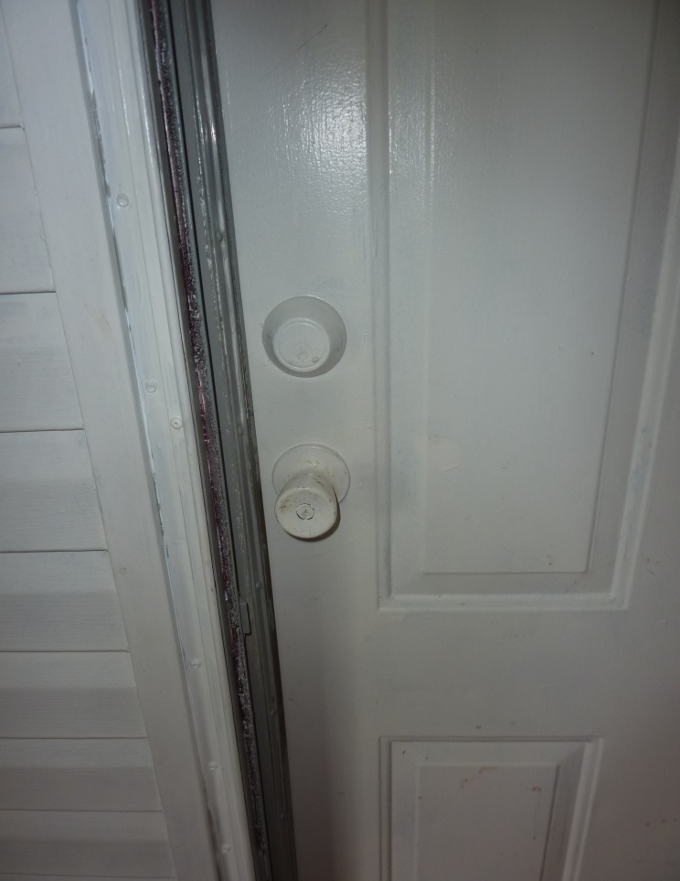

7. Foyer door, at living room, key lock and dead bolt painted over and plugged.

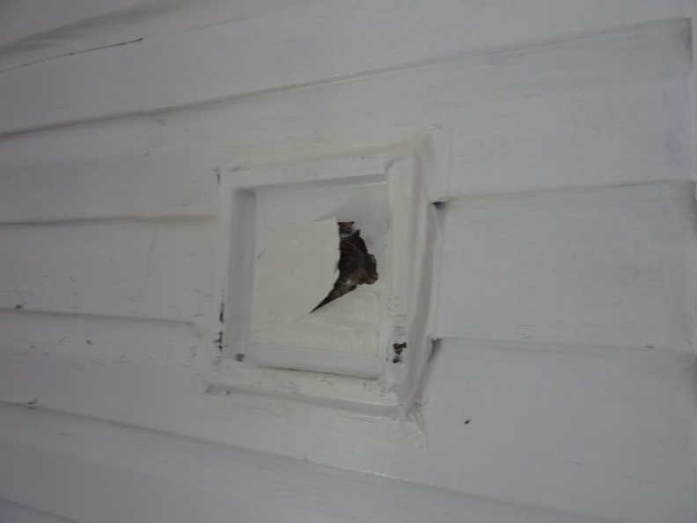

8. An access port, left of above door, is duct taped and painted over.
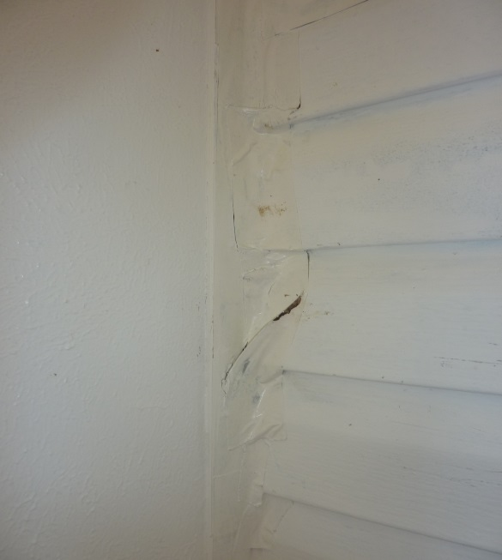

9. The wall, left of access port, is duct taped and painted over.

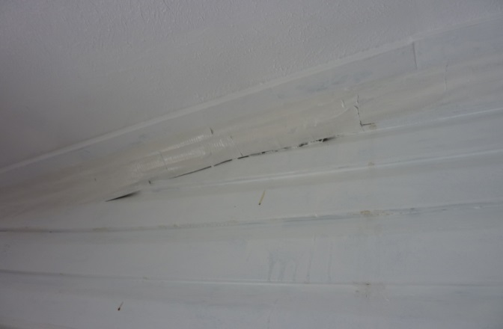

10. Above, the access port, is duct taped and painted over.

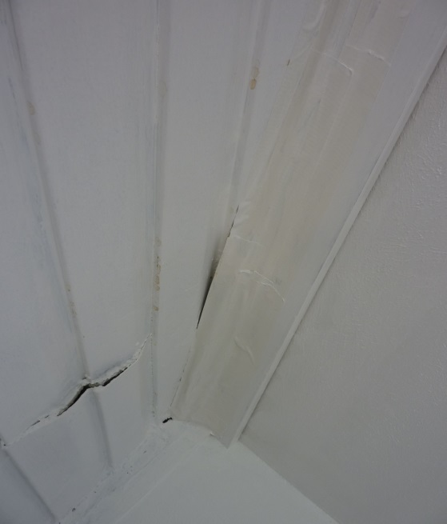

11. To the right is duct taped and painted over.

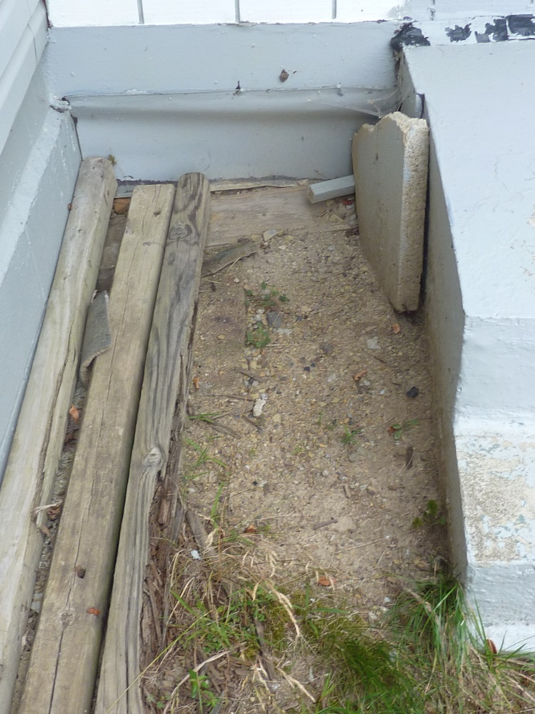

12. Left of foyer, stone covering ground hog entrance

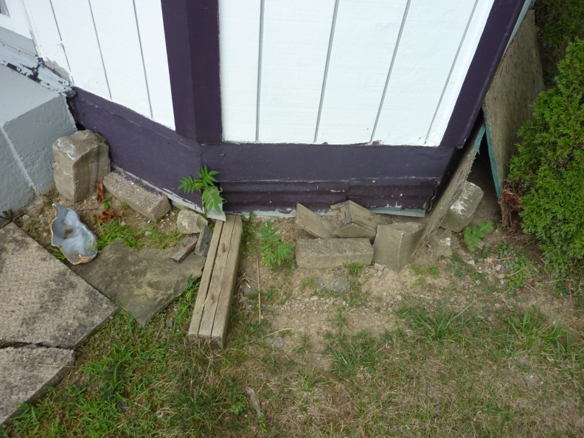

13. Right of front foyer, miscellaneous rocks and wood covering ground hog burrowing.

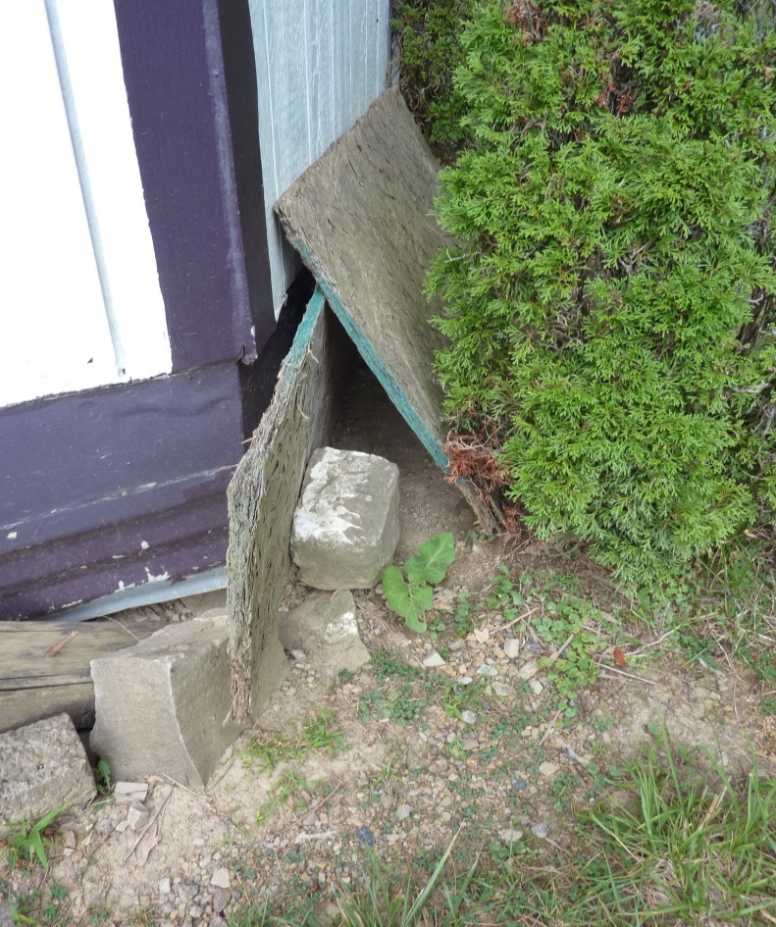

14. Right of foyer, ground hog entrance.

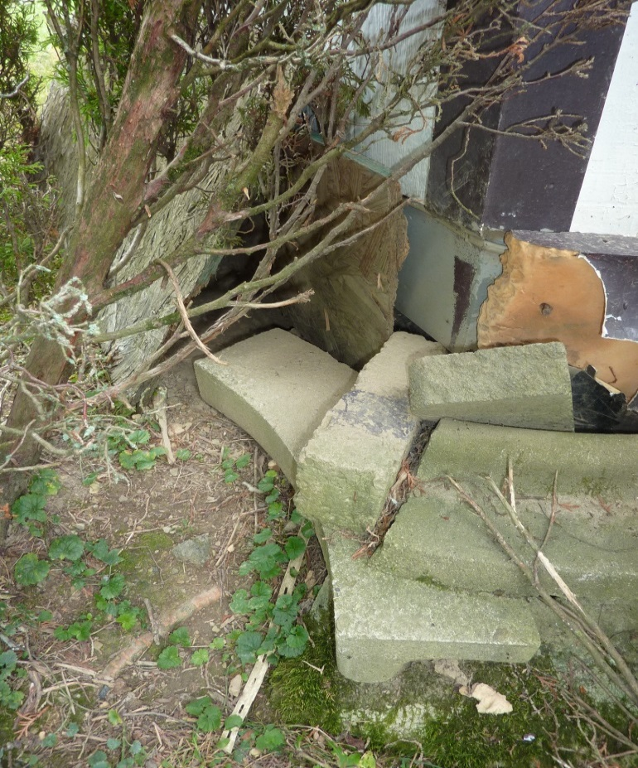

15. Opposite side, ground hog entrance.
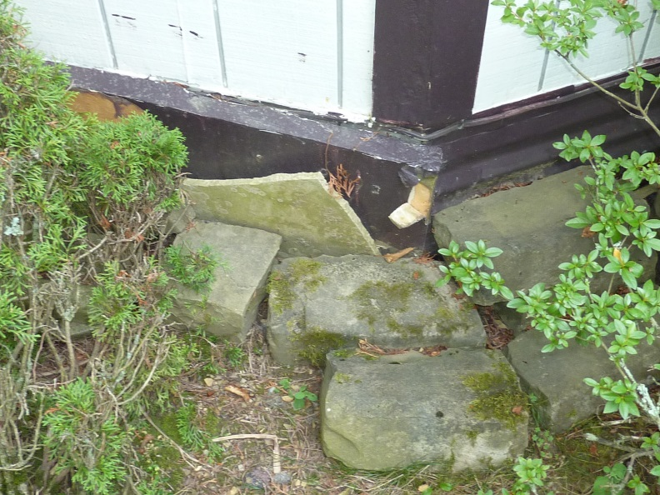

16. Further right of foyer, more stones covering ground hog burrowing

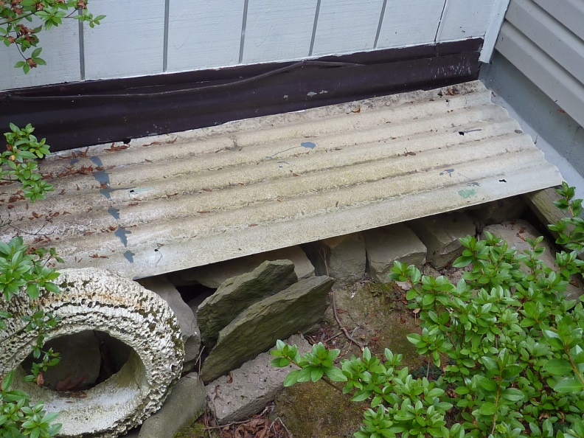

17. Further right of foyer, more stones and miscellaneous debris covering ground hog burrowing. Also visible is an interior Romex wire, from IR light fixture to follow.

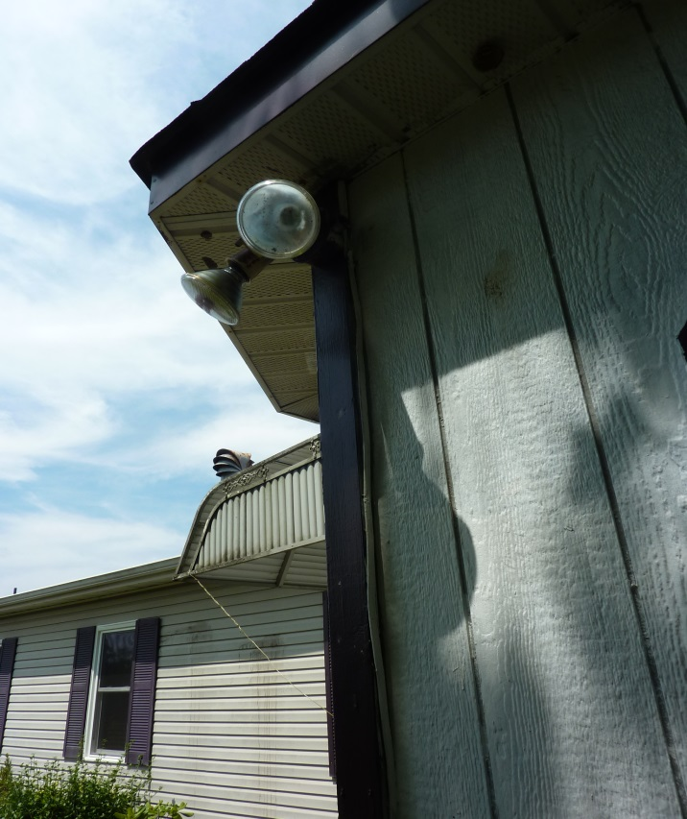
18. Broken IR light fixture, at right of foyer storm door. Wired with interior Romex running down the vertical trim, should be in conduit.

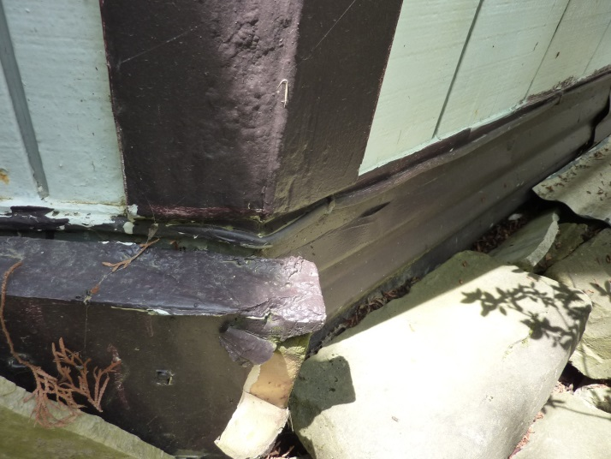
19. IR light Romex running across the front of the foyer and around the corner.
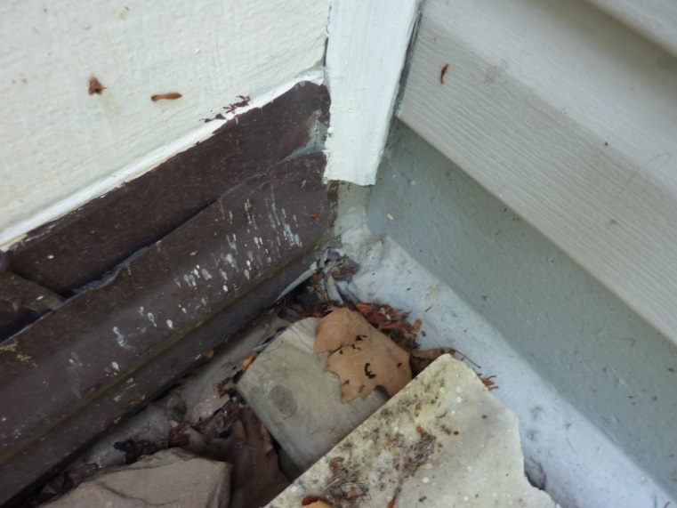
20. IR light Romex ends at corner and through the foundation wall.

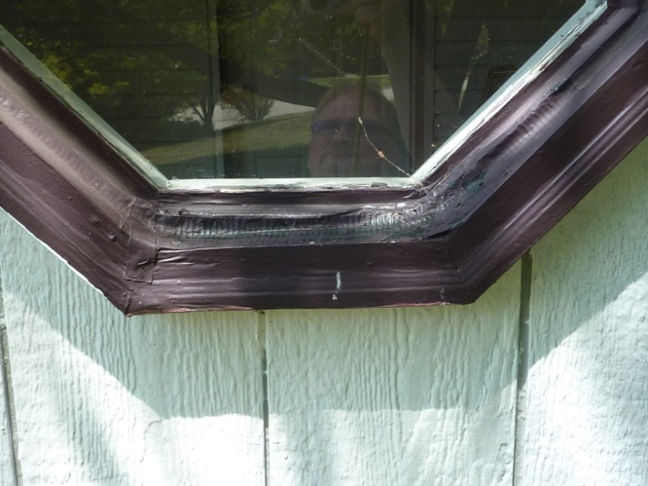
21. Foyer window is duct taped and painted over.
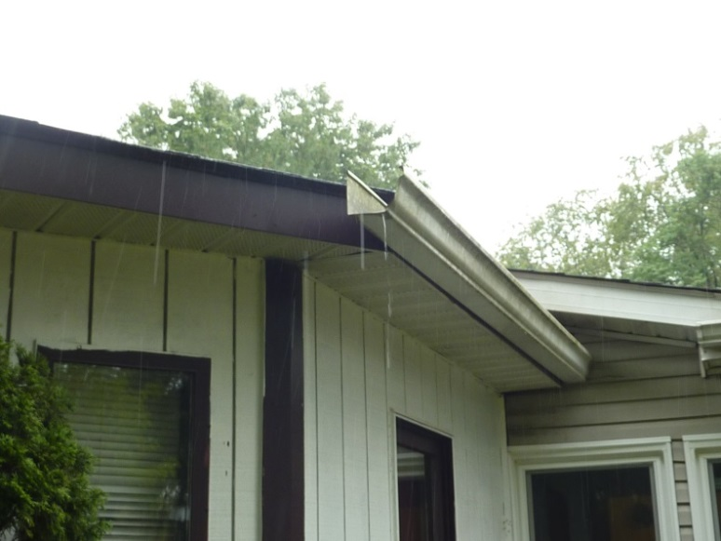
22. Right foyer gutter has no down spout and empties at corner of foyer.
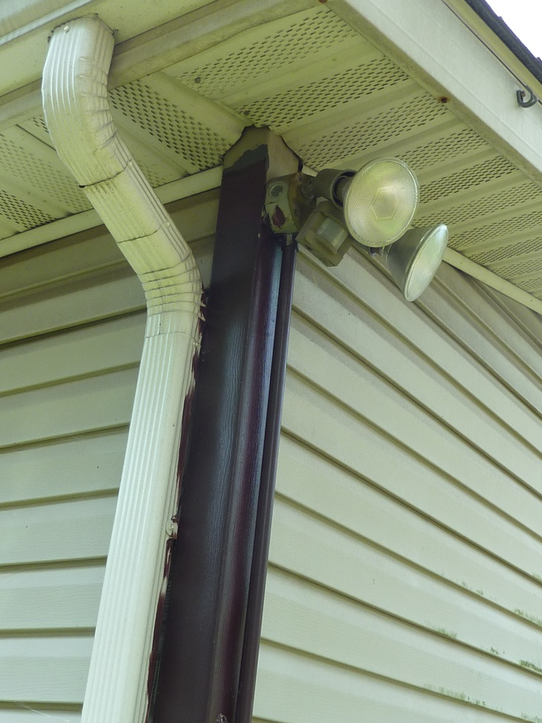
23. Another broken IR light fixture at front right corner of home.

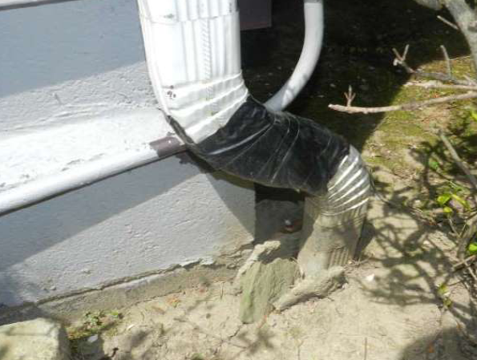

24. The down spout, from picture above, is duct taped together
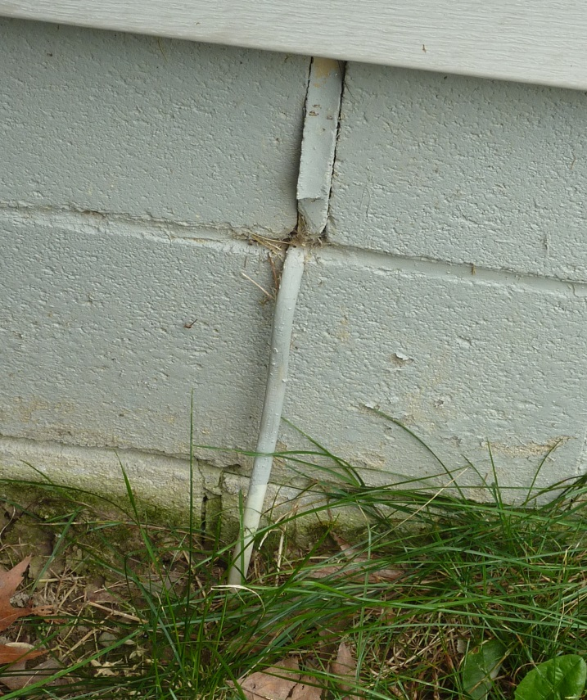
25. At rear right corner of home, an interior Romex wire exits the foundation and routes underground.

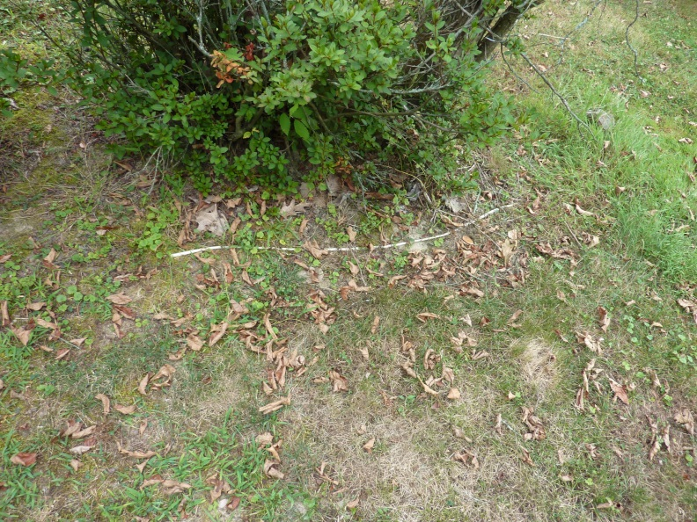
26. The Romex wire appears above ground a few feet away, then back underground.
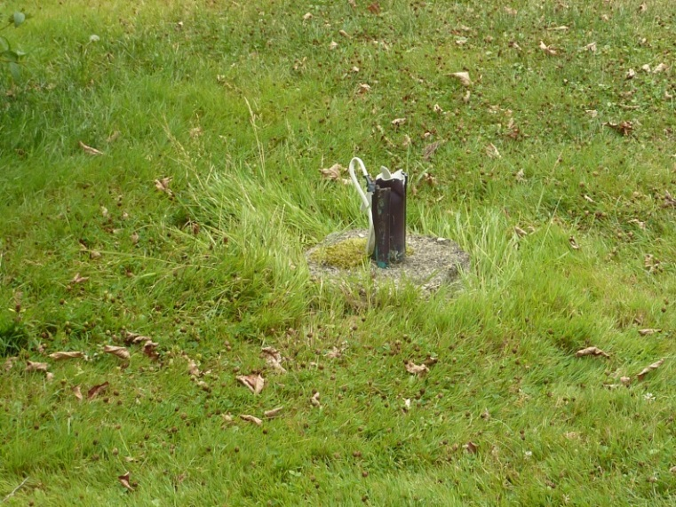
27. It ends at a broken off light post near north property line.

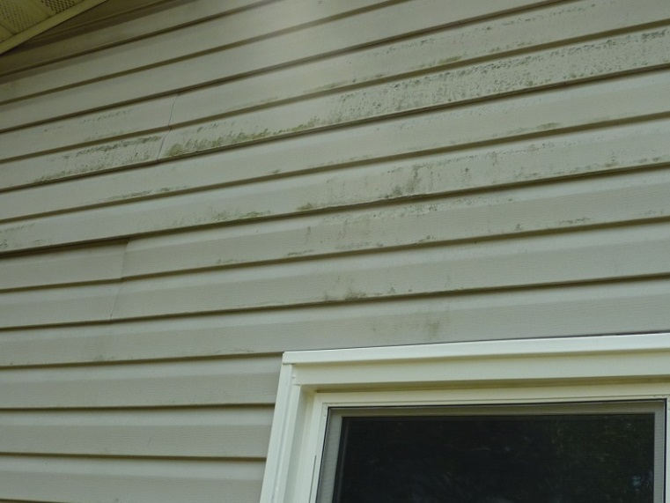
28. At right side wall, black mold appears on the vinyl siding.

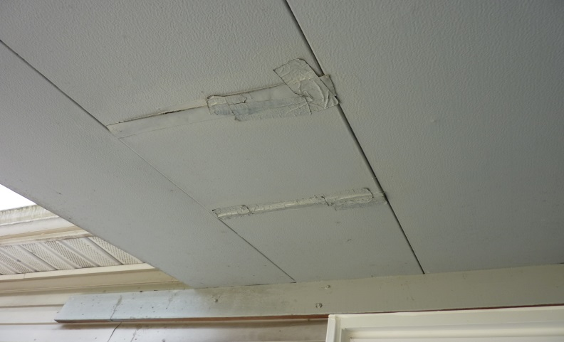

29. At the rear covered patio, ceiling damage is duct tapped and painted over.

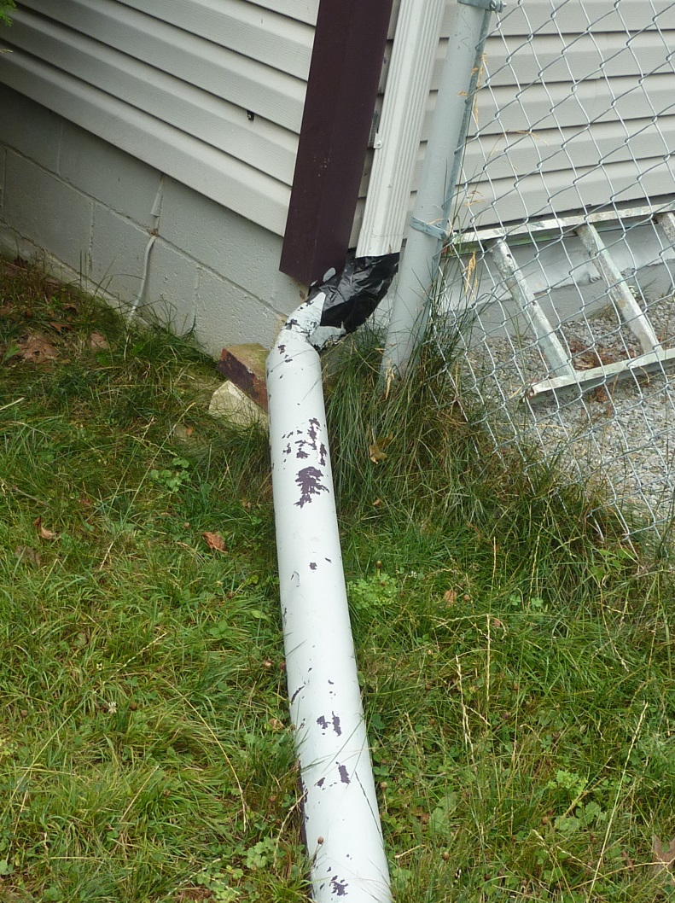

30. At the right rear exterior wall corner. Down spout is duct taped to 4” pipe drain elbow and runs out into yard.

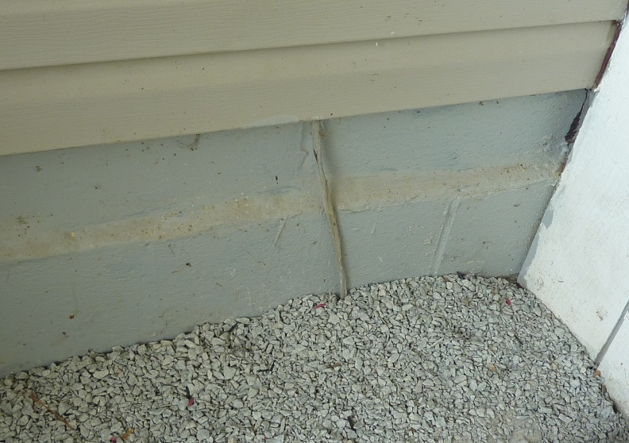

31.At patio corner Romex wire exits the foundation and runs behind vinyl siding. Should be in conduit.

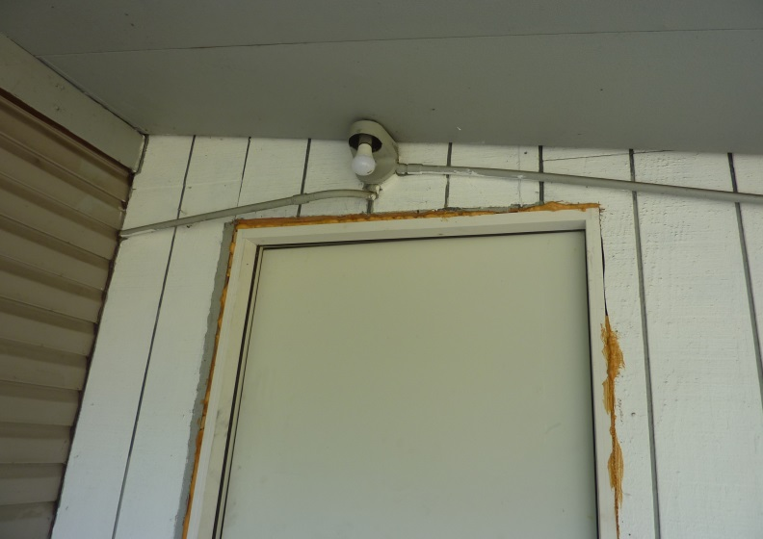

32. Romex exits siding and runs to light fixture and then to exterior corner.

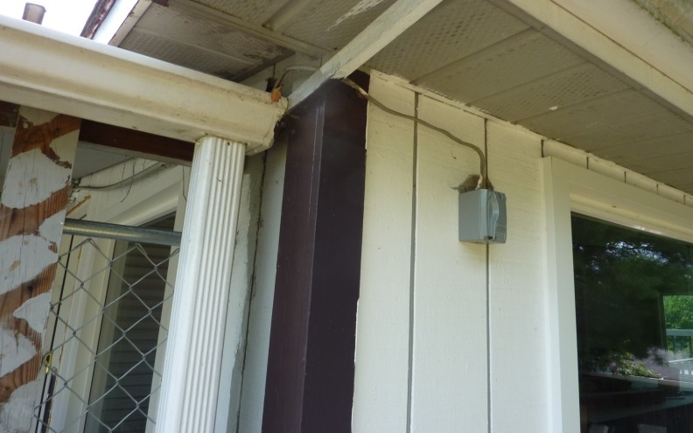

33. At the corner it returns to interior Romex and ends at an exterior box. Should be in conduit.

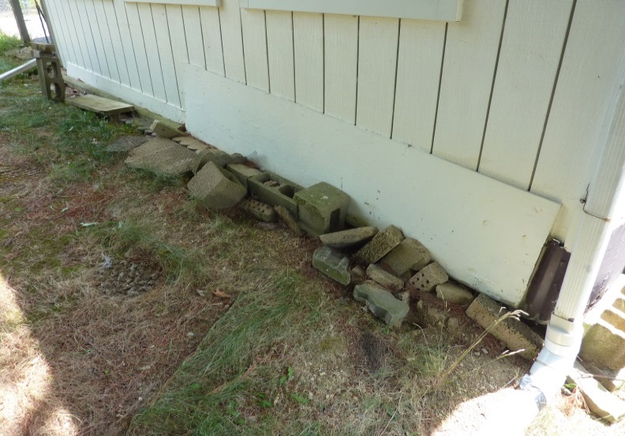

34. Rear sun room wall skirting covered with wood. Rocks and stones fill in ground hog borrowing.
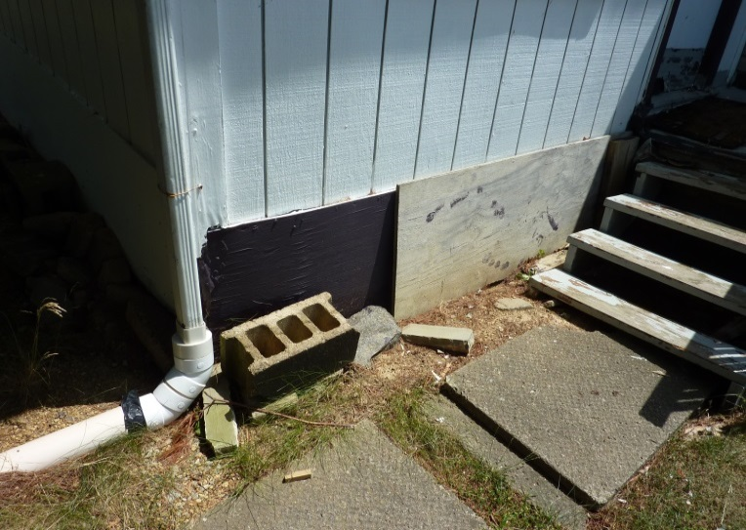

35. At side of sun room, wall skirting covered with wood. Stones fill in ground hog borrowing.

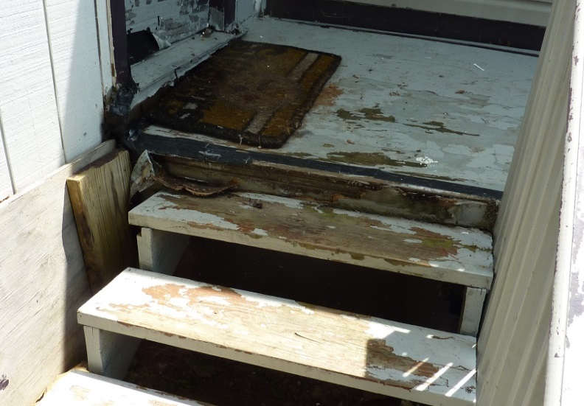

36. The post support, for the Sun room deck landing, has collapsed creating a 3 inch drop at the top stair. The area is also duct taped

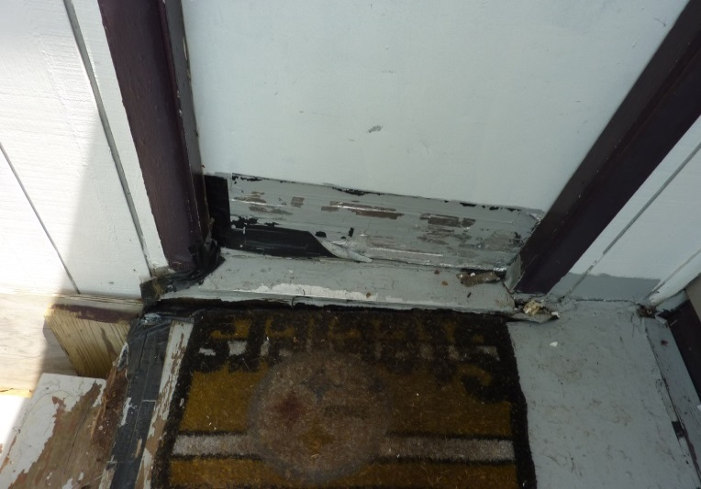

37. The bottom and threshold of the sun room door is duct taped and painted over.
,

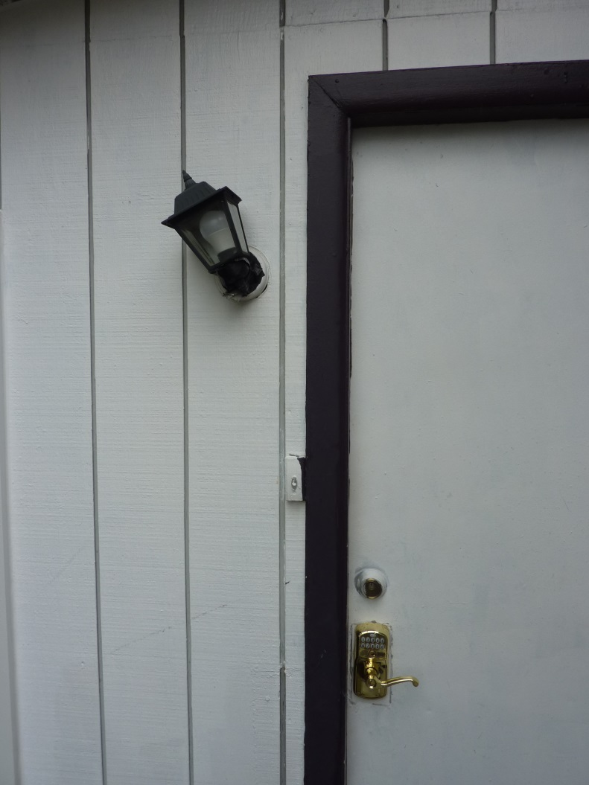
38. The sun room entrance light has been duct taped on. Doorbell switch has been painted over multiple times. It does not work.

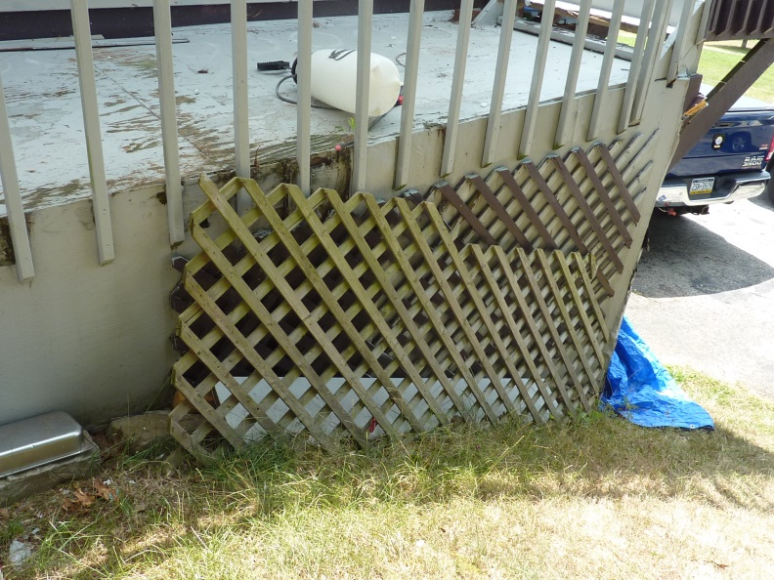
39. Decorative lattice has fallen off.

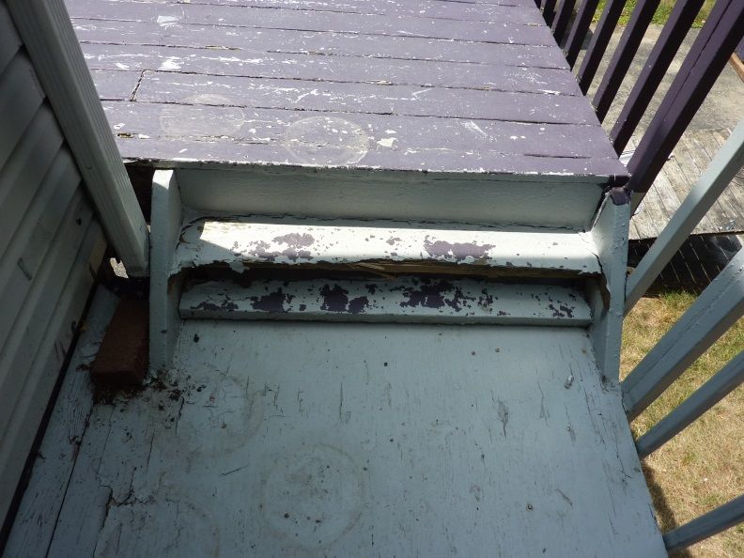
40. At the end of sun room deck, the first step of the transition stairs is broken off.

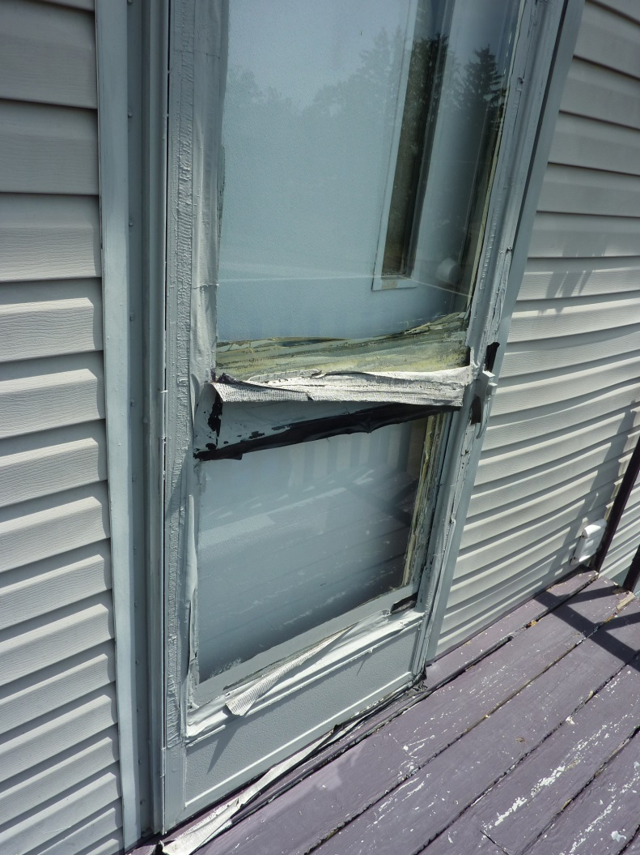
42. On the transitional deck, the side storm door is completely duct taped shut and cannot be opened to inspect the inside door.

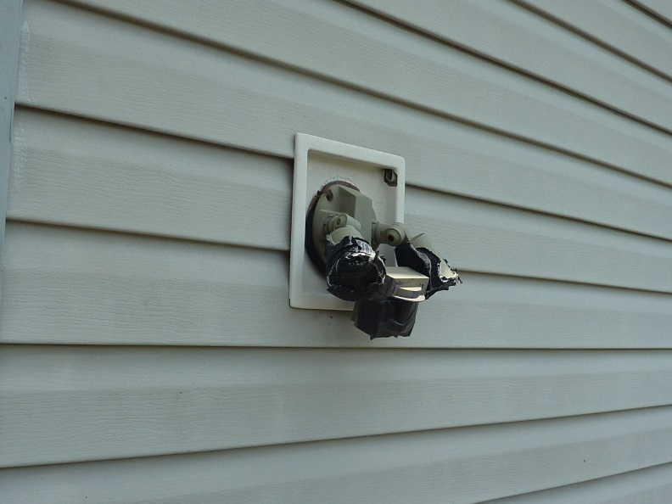

43. To the right of the side storm door is a broken IR light fixture all duct taped up.

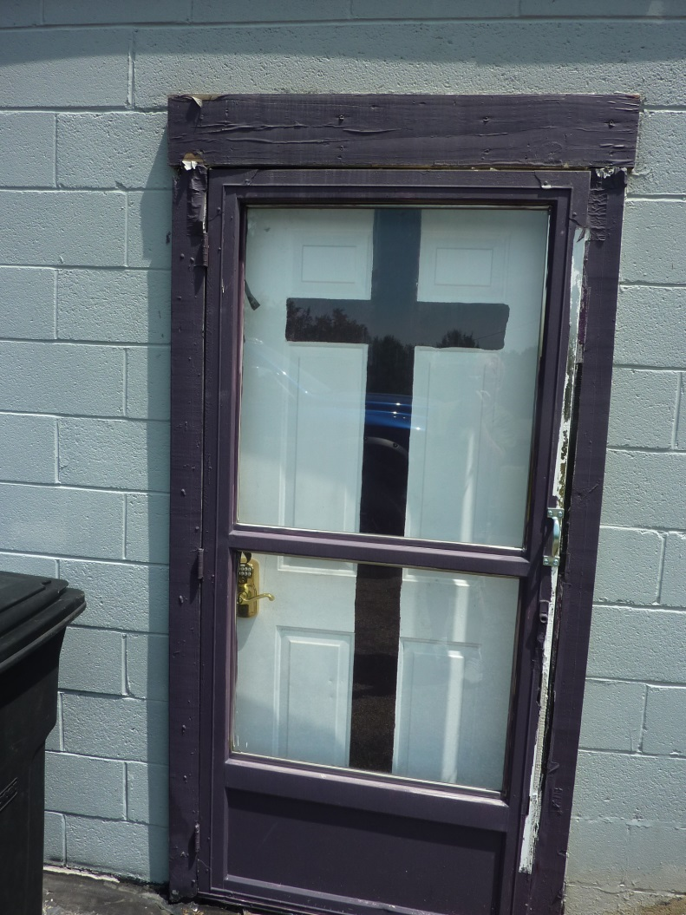
44. The side basement entrance storm door has been duct taped inside and out along with the trim. Also was painted over.

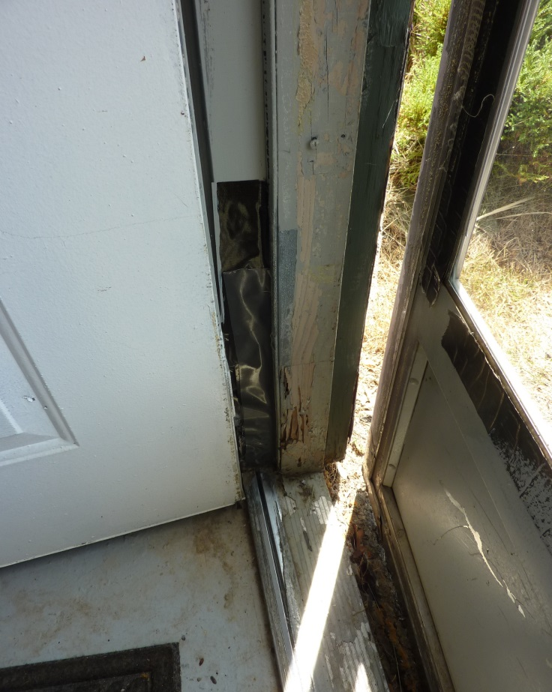

45. The strike-edge jam has termite damage. Also duct tape used to cover other damage

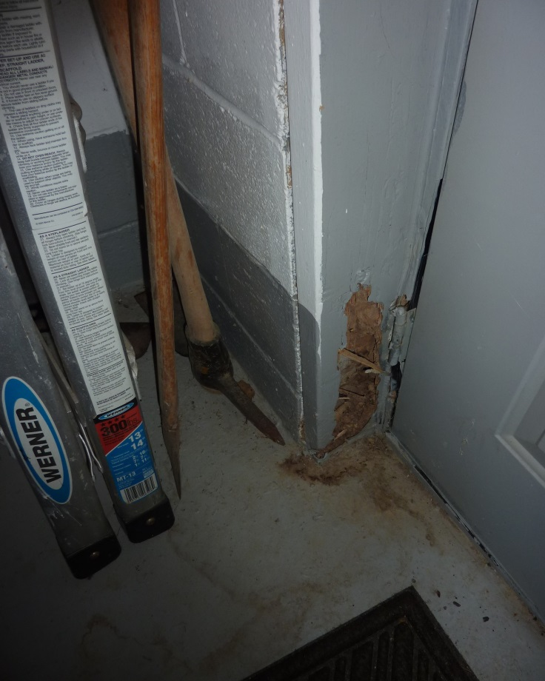

46. The king stud has been eaten away by terminates. This damage extends up the stud behind the multi layers of paint.

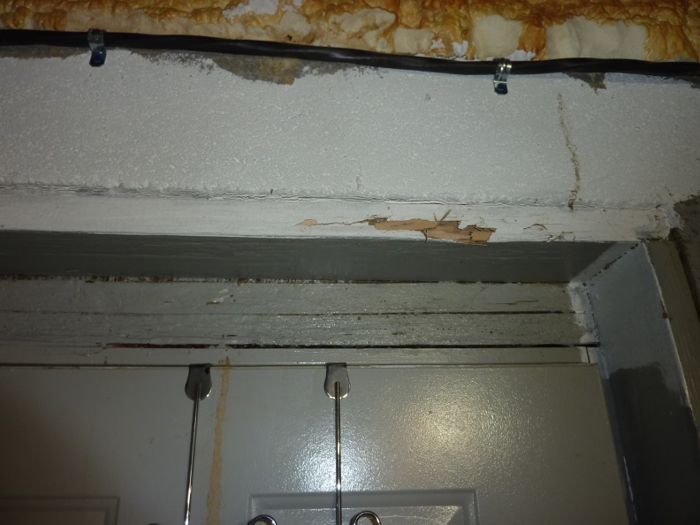

47. The header, head jam and head casing have also sustained damage from termites.

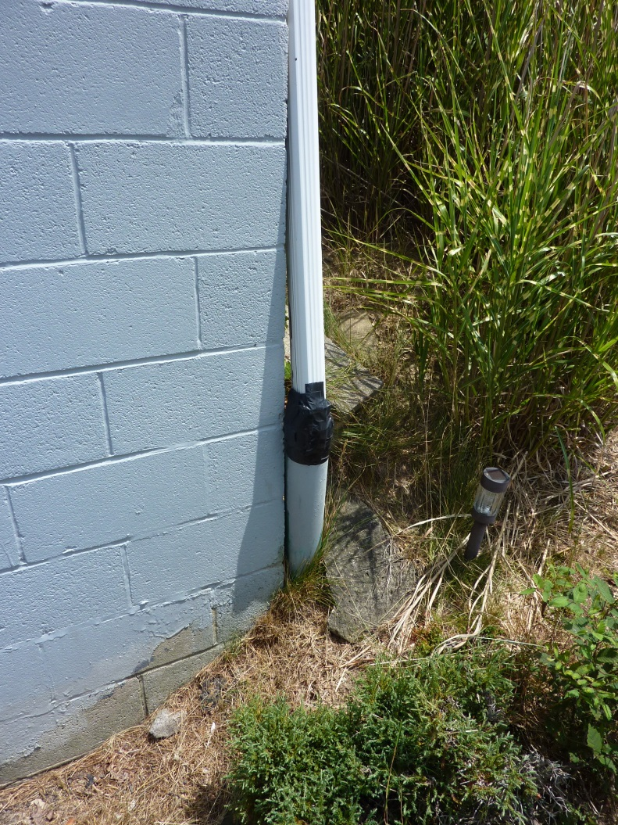

48. The down spout, next to basement entrance, has been sealed with duct tape to a 4 inch pipe.

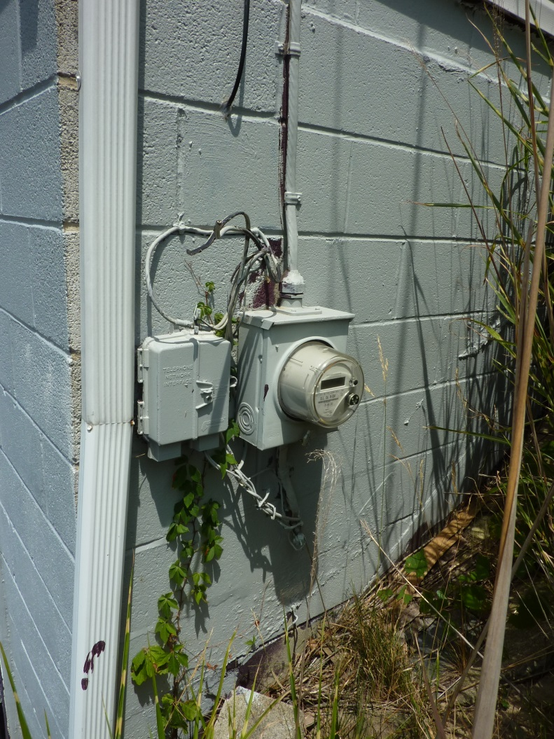

49. Opposite wall from down spout is a collection of various cut and dangling wires with an abandoned phone relay box.

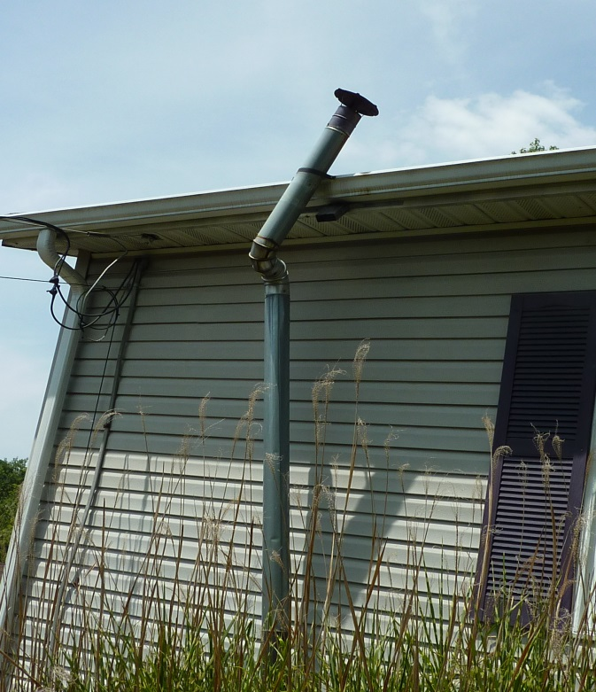

50. Water heater vent piping has broken away from its rusted wall strap.
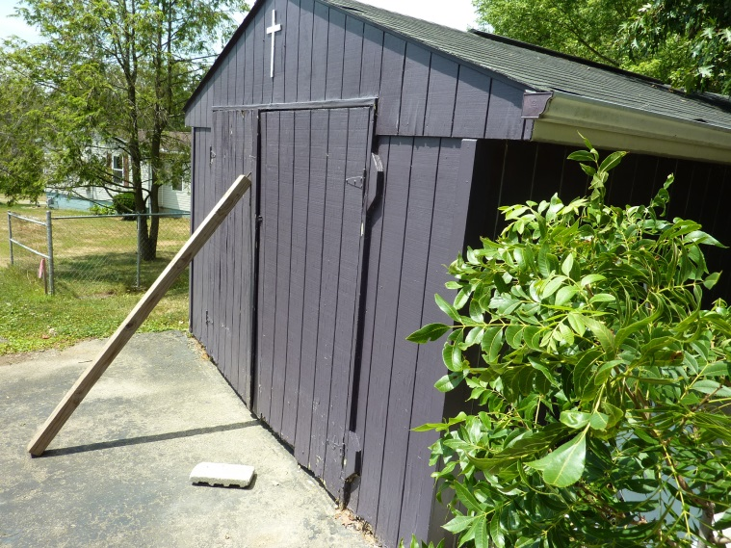

51. Outbuilding door latch is missing. Doors are warped and require 4”x4” post to hold shut.

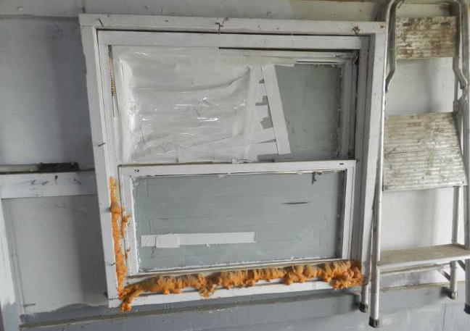

52. Outbuilding right interior window duct taped and painted over.

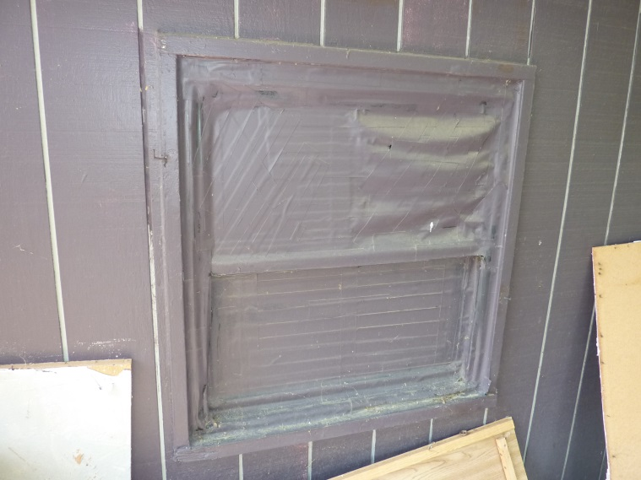

53. Outbuilding right exterior window duct taped and painted over.

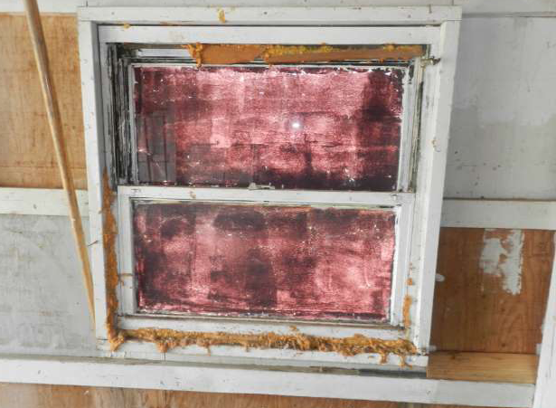

54. Outbuilding left interior window painted over.

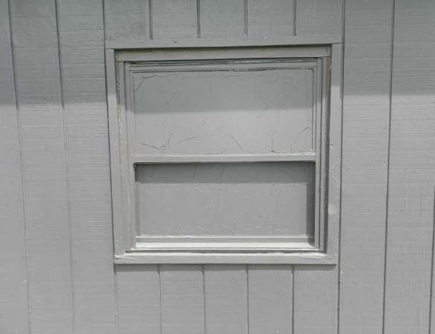

55. Outbuilding left exterior window painted over.

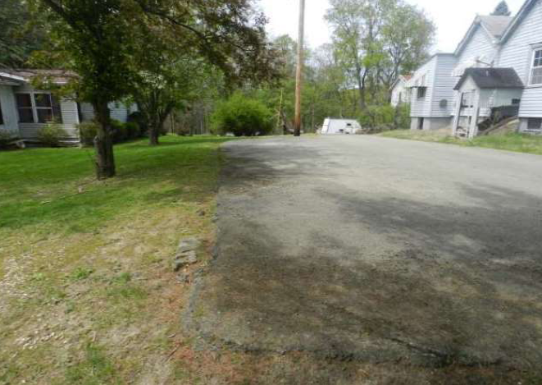

56. The abandoned home, at 1034 Logan Road, has a portion of its driveway situated upon
the property located at 1036 Logan Road. Parcel ID: 0751-F-00170-0000-00

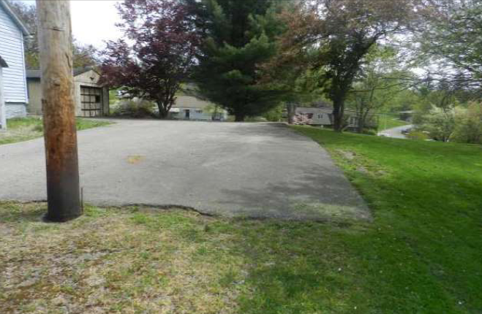

57. Opposite view. The Encroachment measures 12 foot x 47 foot. Parcel ID: 0751-F-00163-0000-00

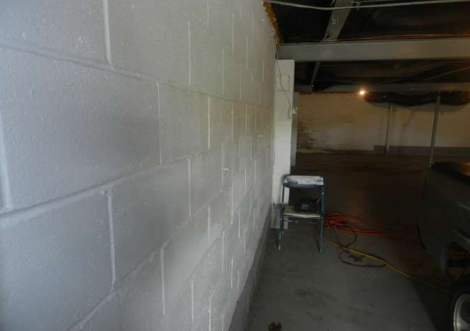

58. Rear basement wall shows signs of bowing.

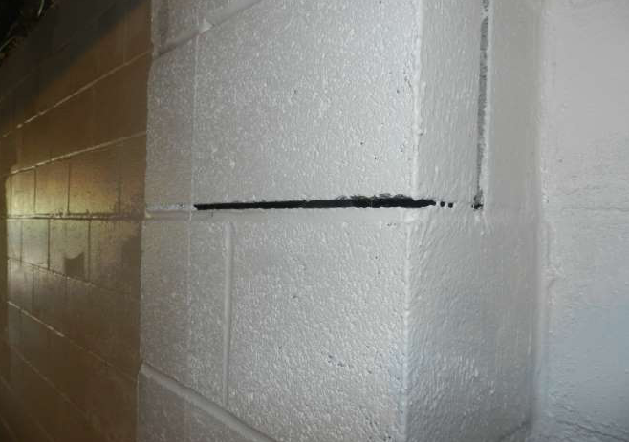

59. Settlement on rear foundation wall.

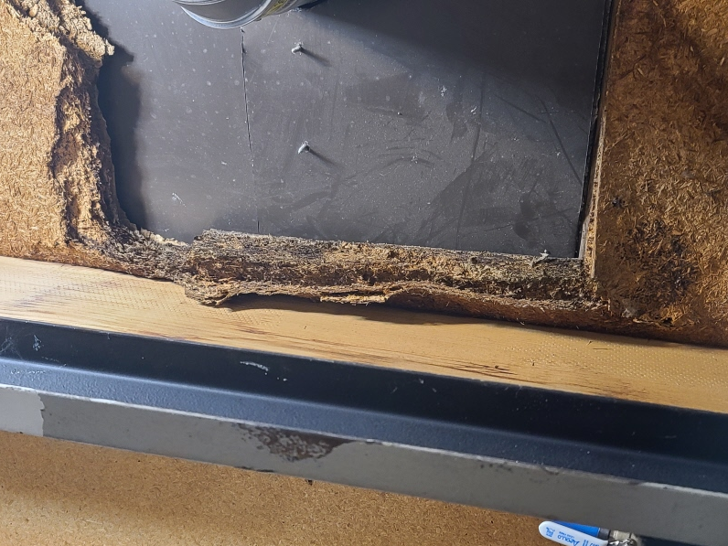
60. Damage to first floor from AC evaporator leakage.

INTERIOR
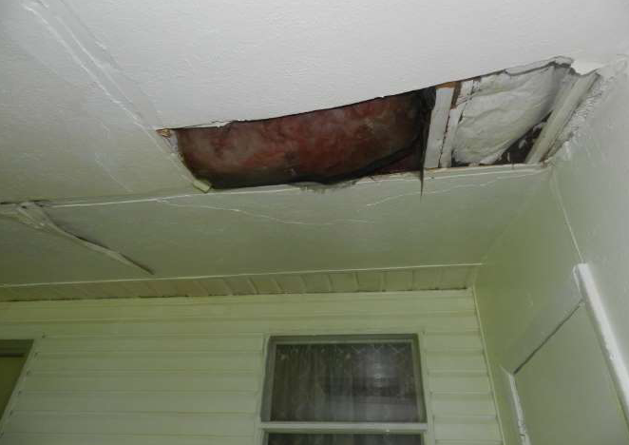
61. Hole in the roof of family room.

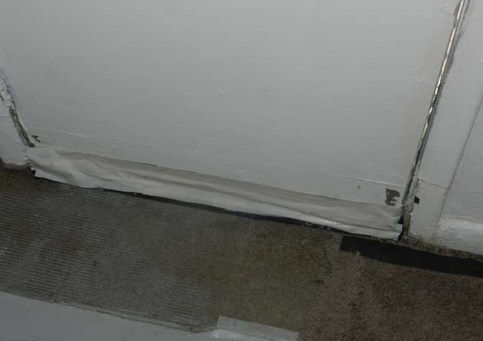

62. Side family room door thresh seal missing. Duct tape seals the door.

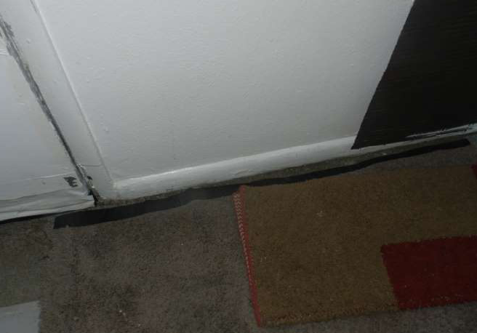

63. Trim in family room taped.

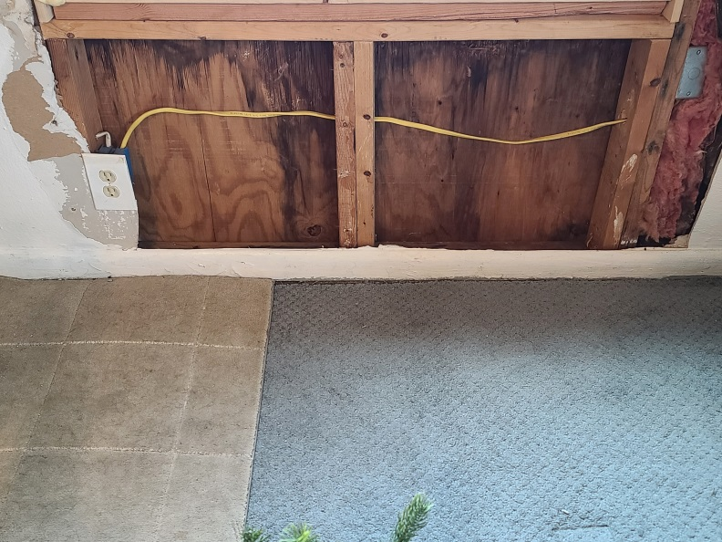
64. Interior wall removed to perform carpenter ant abatement. Wall not repaired.

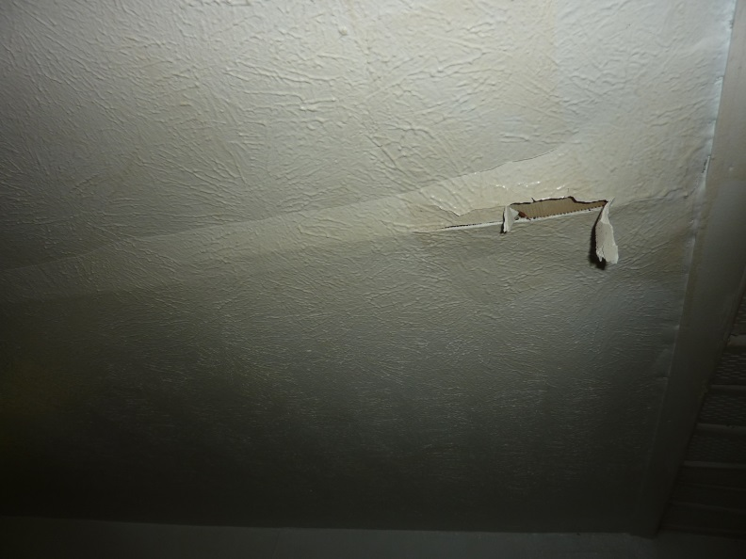

65. More family room roof damage.

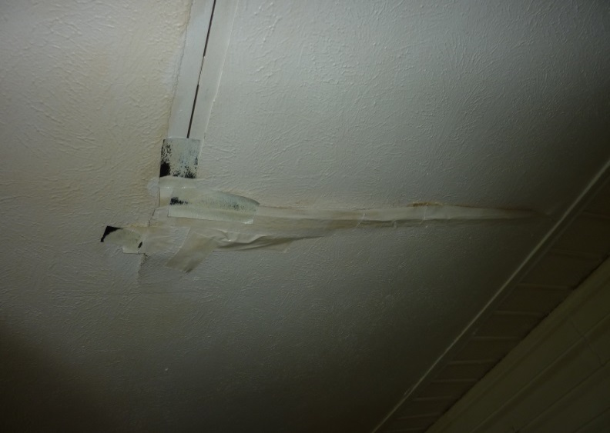

66. More family room roof damage.

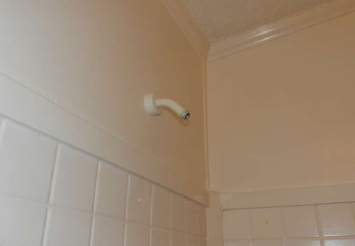
67. Shower head missing in bed room 1, bath1 (BR1)

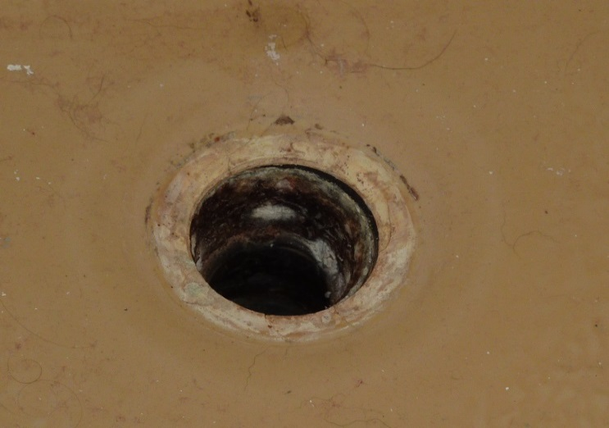

68. Drain in bath 1 is corroded away and drain pipe has dropped down allowing drain water to leak into basement. (BR1)

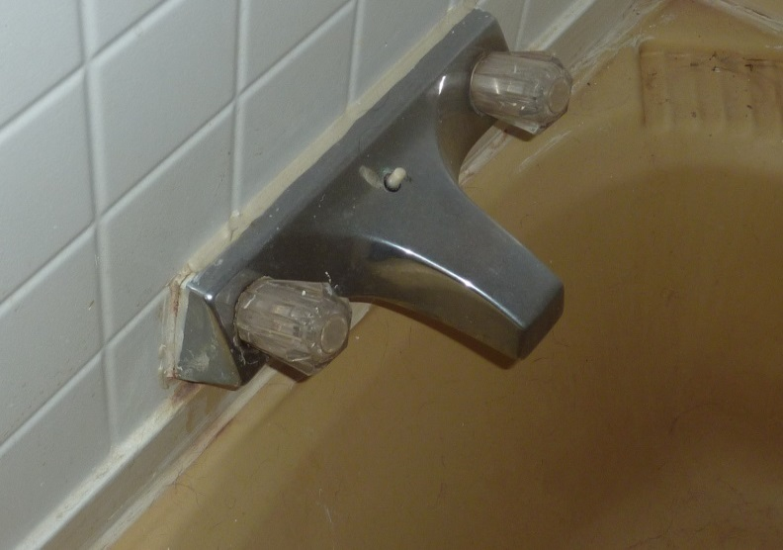
69. Shower diverter push/pull knob missing, bath 1. (BR1)

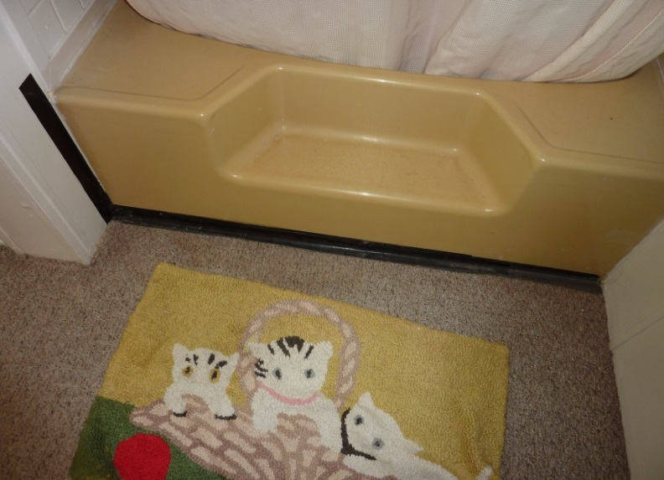
70. Bath tub is duct taped, bath 1. (BR1)

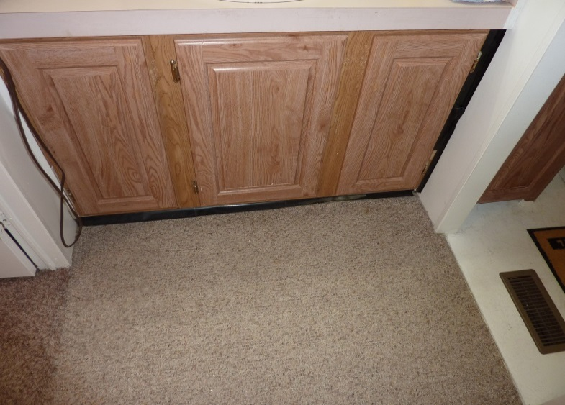

71. Vanity is duct taped, bath 1. (BR1)

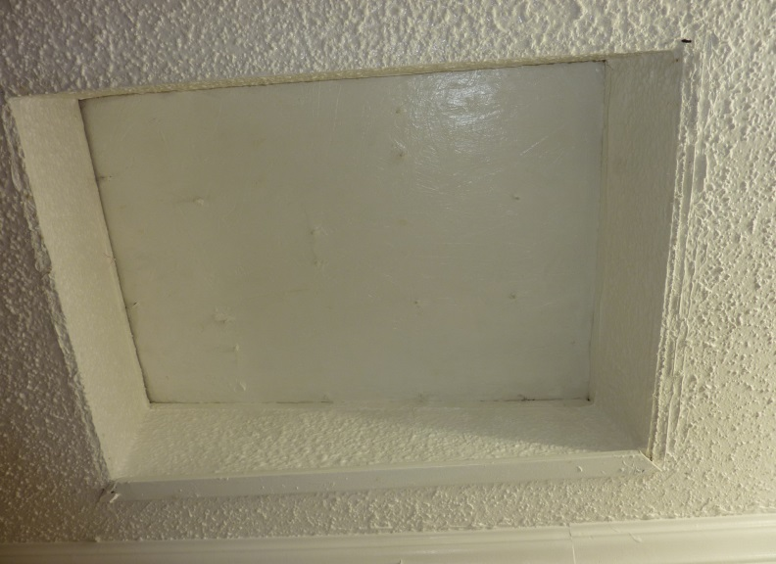

72. Skylight removal repair incomplete. Can see end of asphalt roofing nails protruding through plywood patch. Bath 1 (BR1)

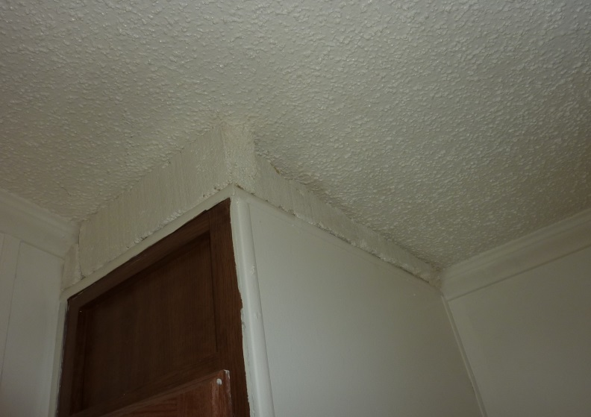

73. Unknown Styrofoam fill-in above pantry storage cabinet. Bath 1 (BR1)

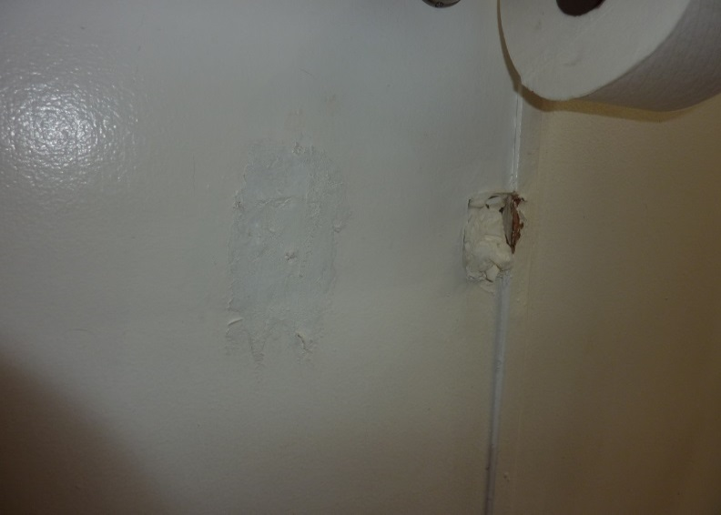

74. Wall damage, (BR1)

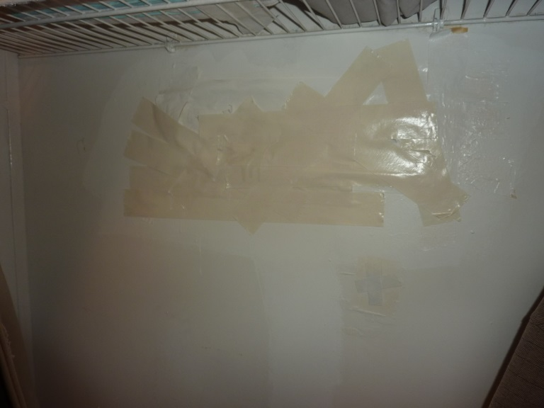

75. Multiple holes tapped over and painted in walk in closet. (BR1)

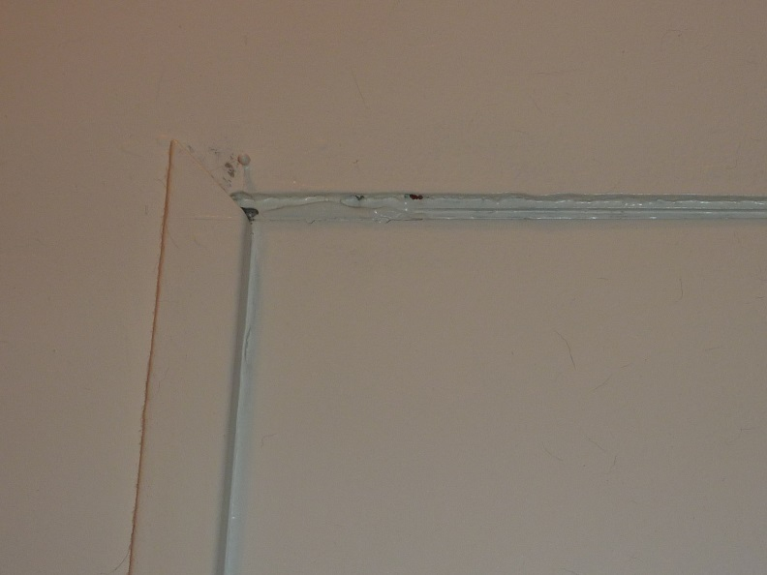
76. Trim on bath 1 door missing. (BR1)

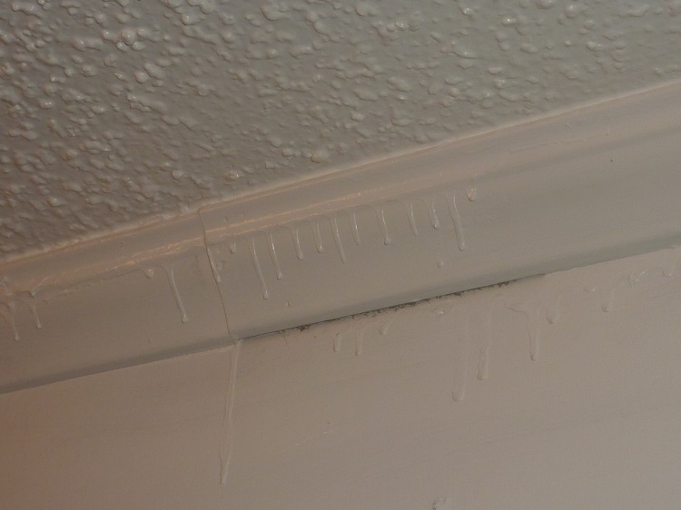

77. Paint runs throughout BR1. Poor quality latex paint (BR1)

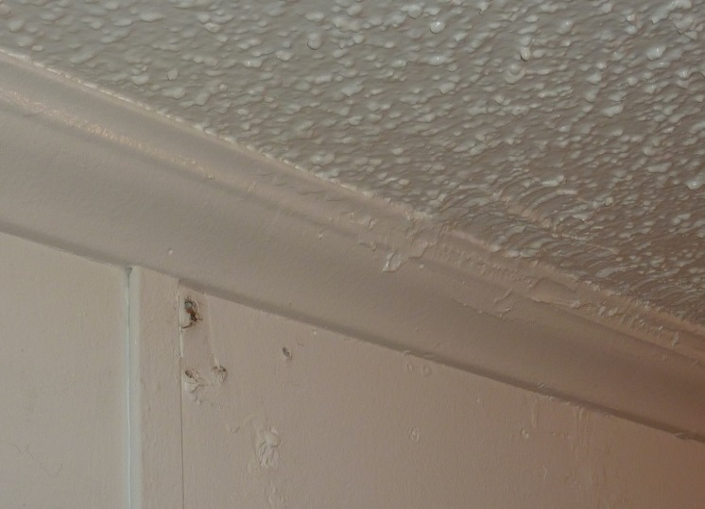

78. Wall damage, caked on paint and runs (BR1)

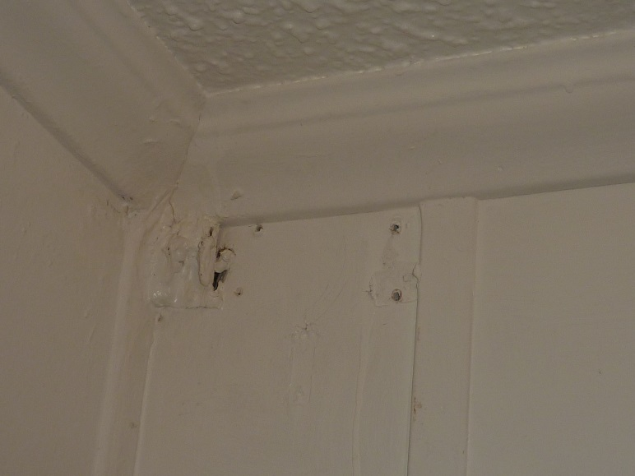

79. The overall appearance of the room is poor. Heavy layers of poor quality latex paint and poor painting technique. (BR1)

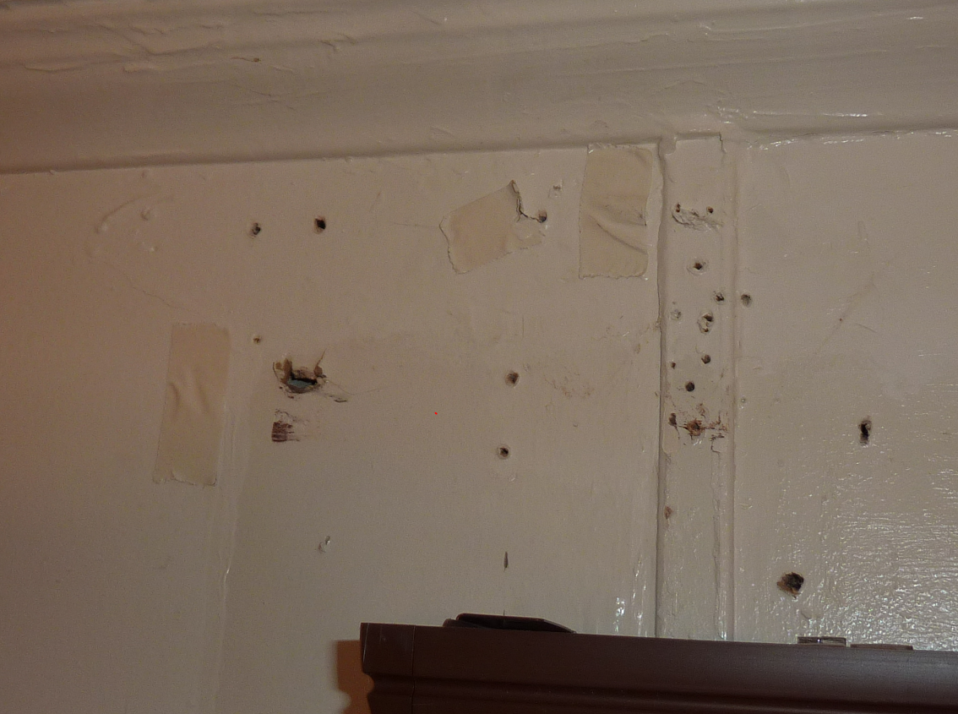

80. Wall damage above left window (BR2)

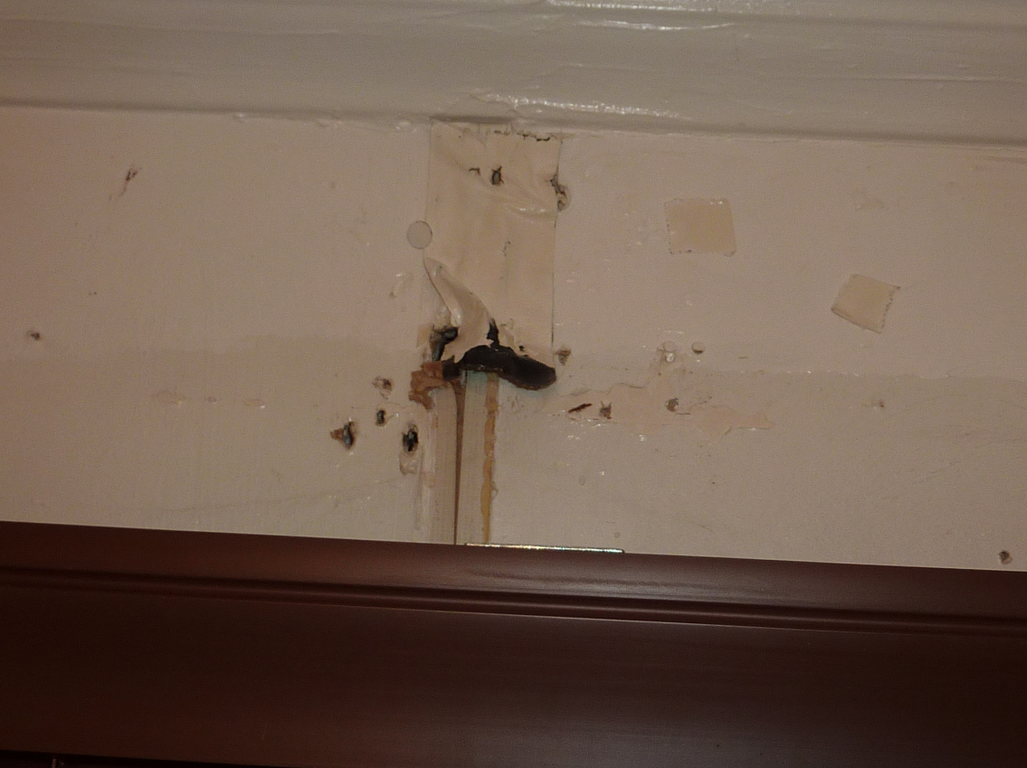

81. Wall damage above center window (BR2)
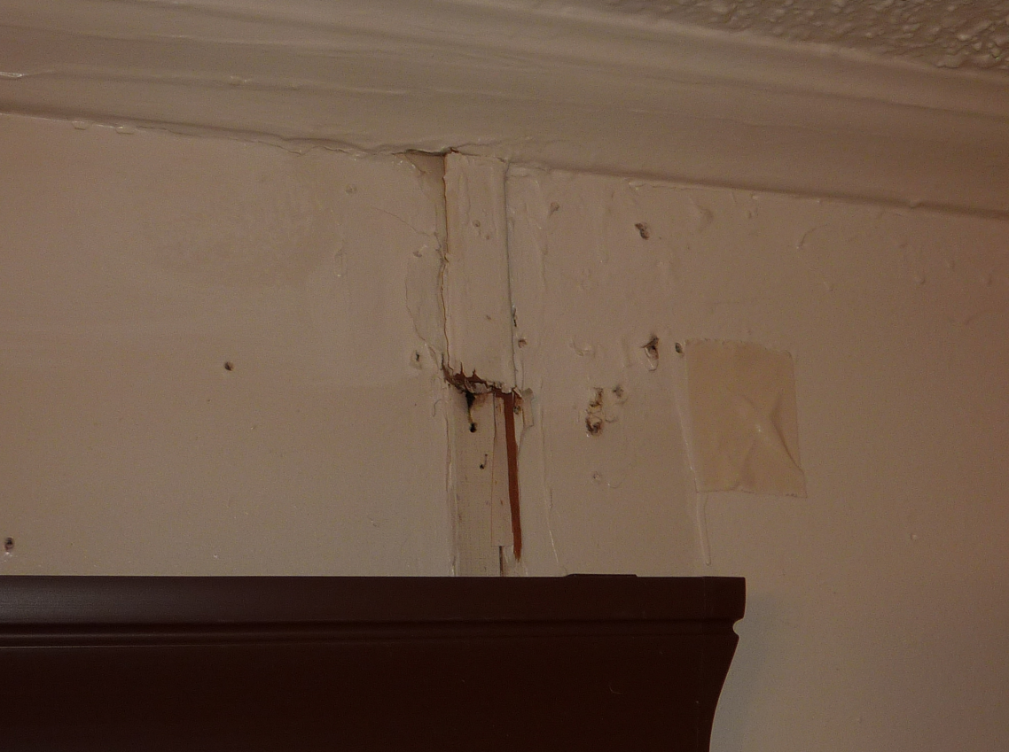

82. Wall damage above right window (BR2)

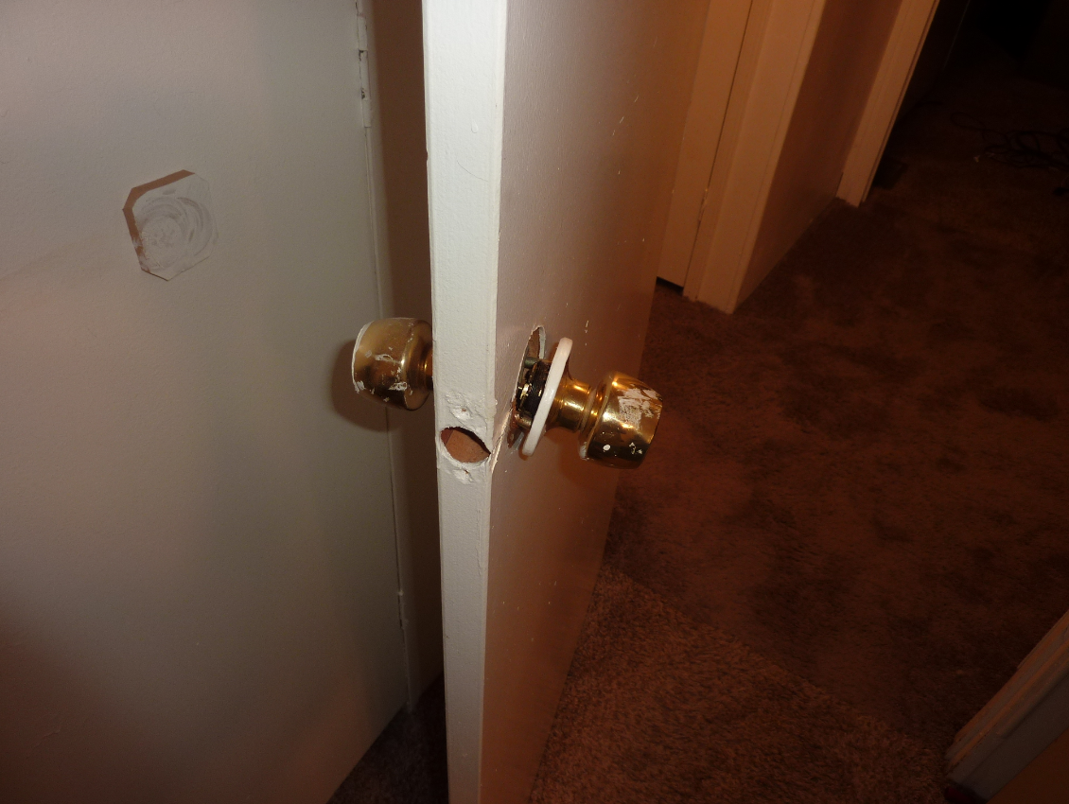

83. Broken door handle and missing lock cylinder (BR2)

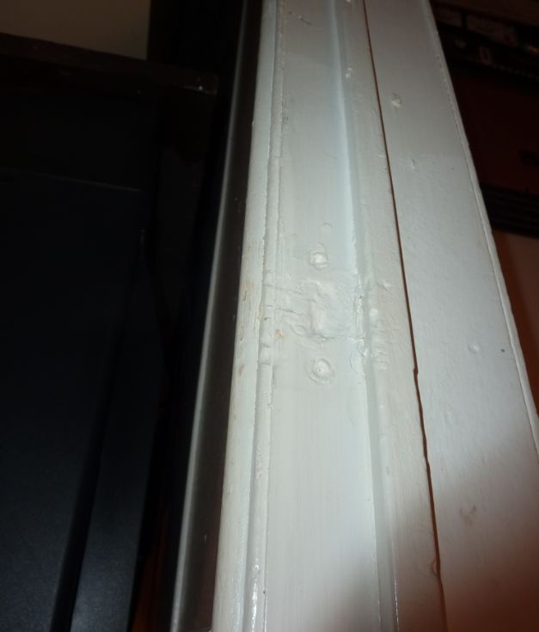

84. Filled in strike plate recess and missing strike plate. (BR2)

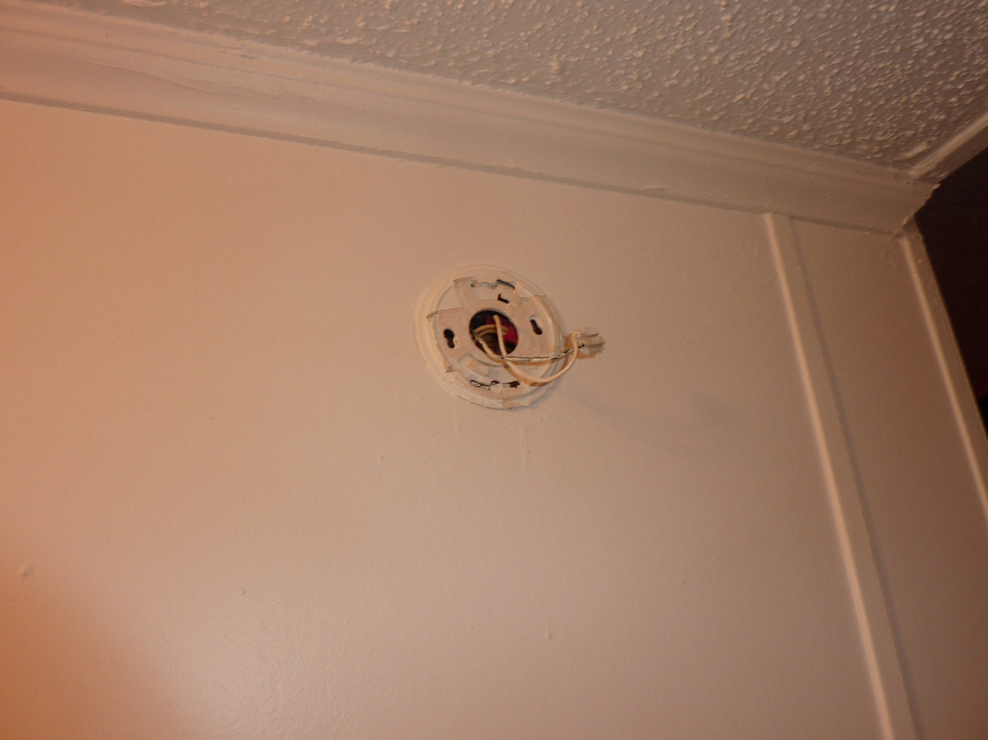

85. Missing door bell fixture, hallway.
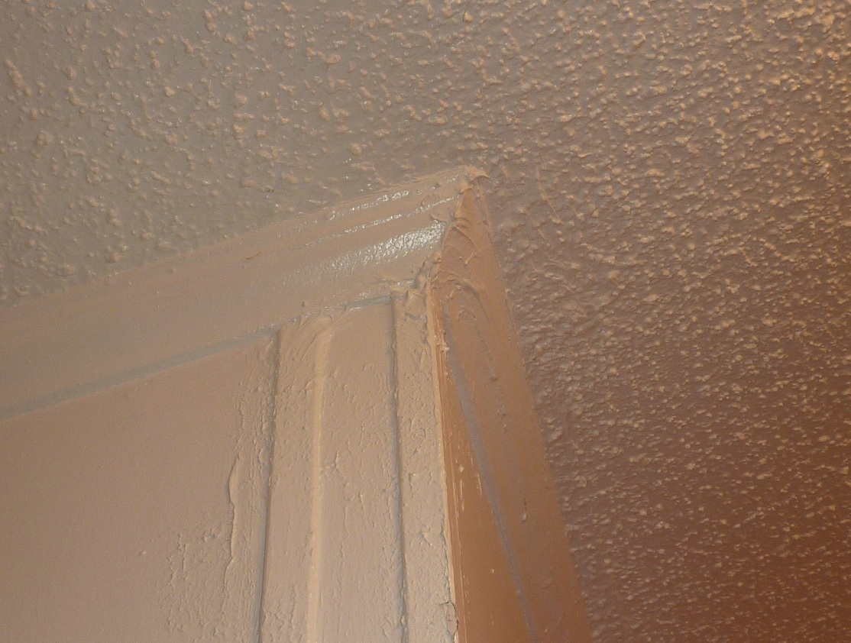

86. Gobbed on paint and filler, hallway.

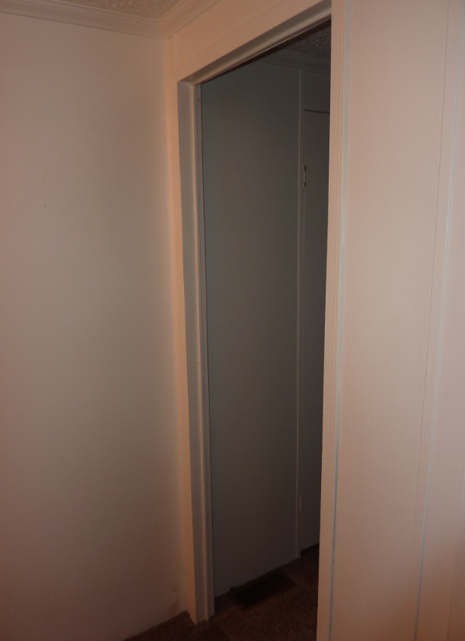

87. Missing door. (BR3)

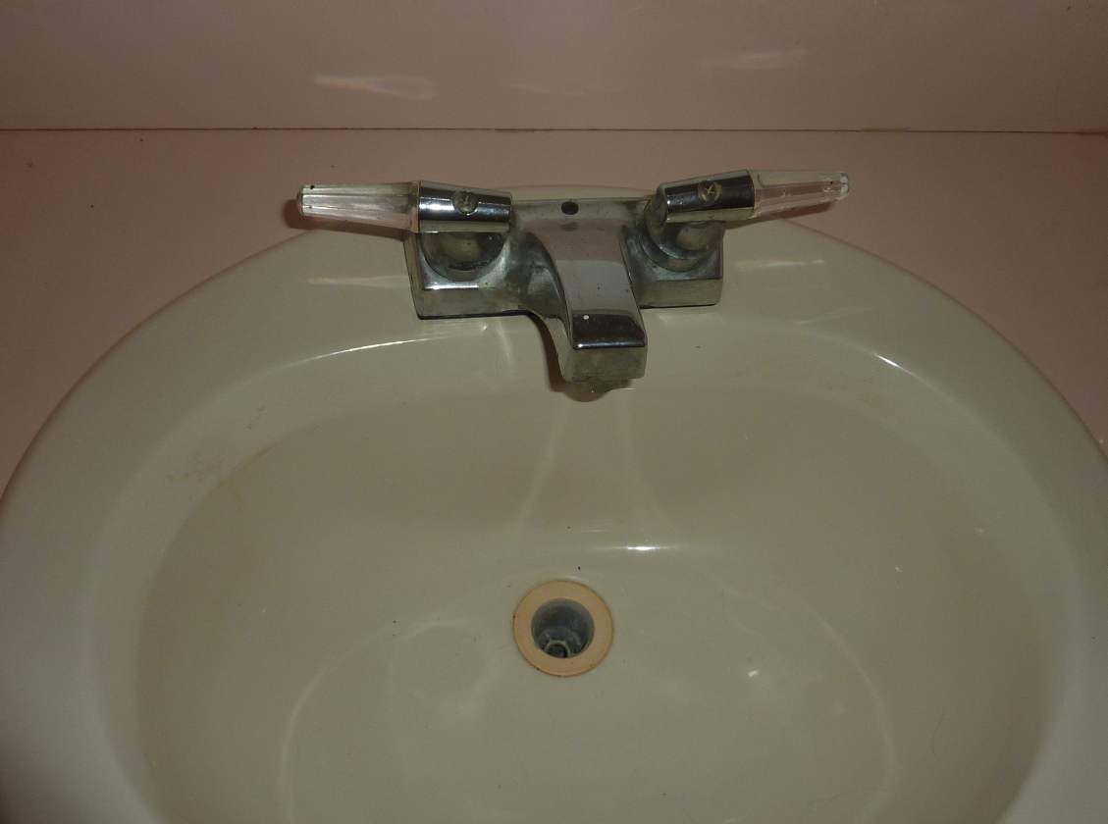

88. Missing pop-up drain assembly and drain plug. (BATH2)

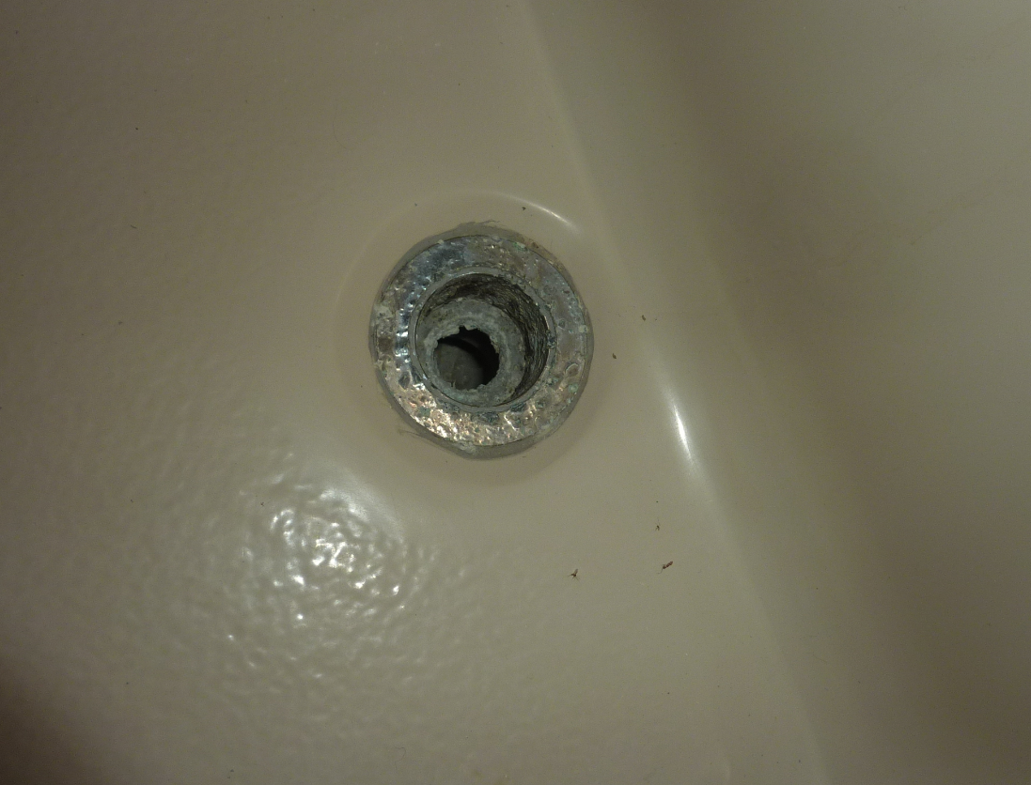

89. Corroded away drain assembly and missing drain plug. (BATH2)

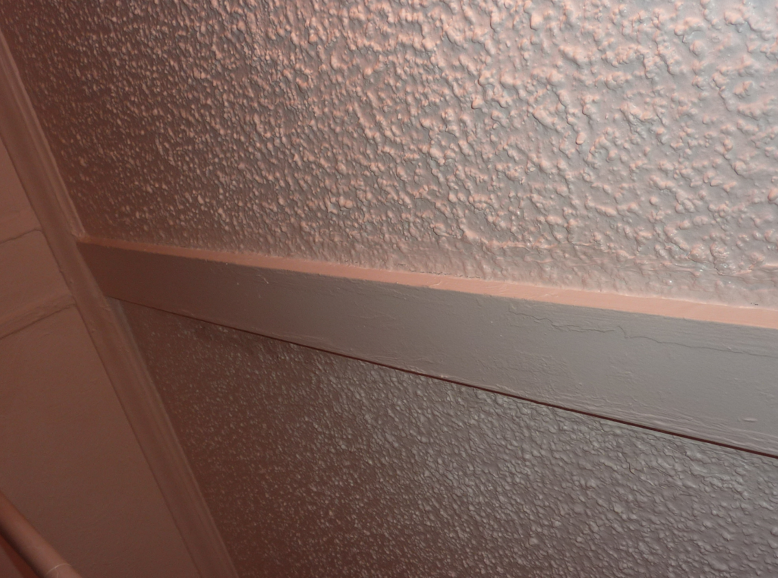

90. Arbitrary unknown trim piece running across ceiling (BATH2)
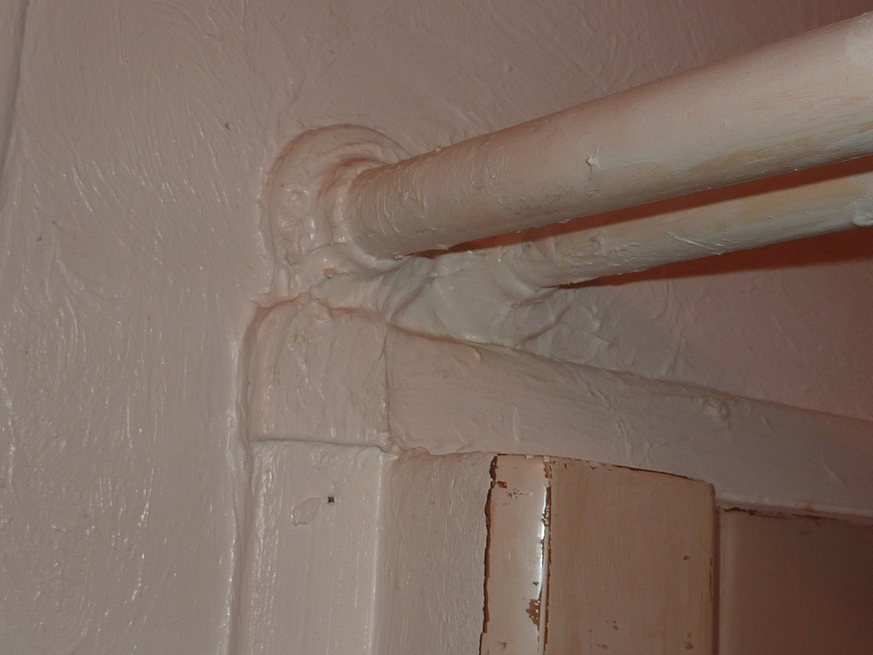

91. Gobbed on filler and paint at shower curtain rod. (BATH2)

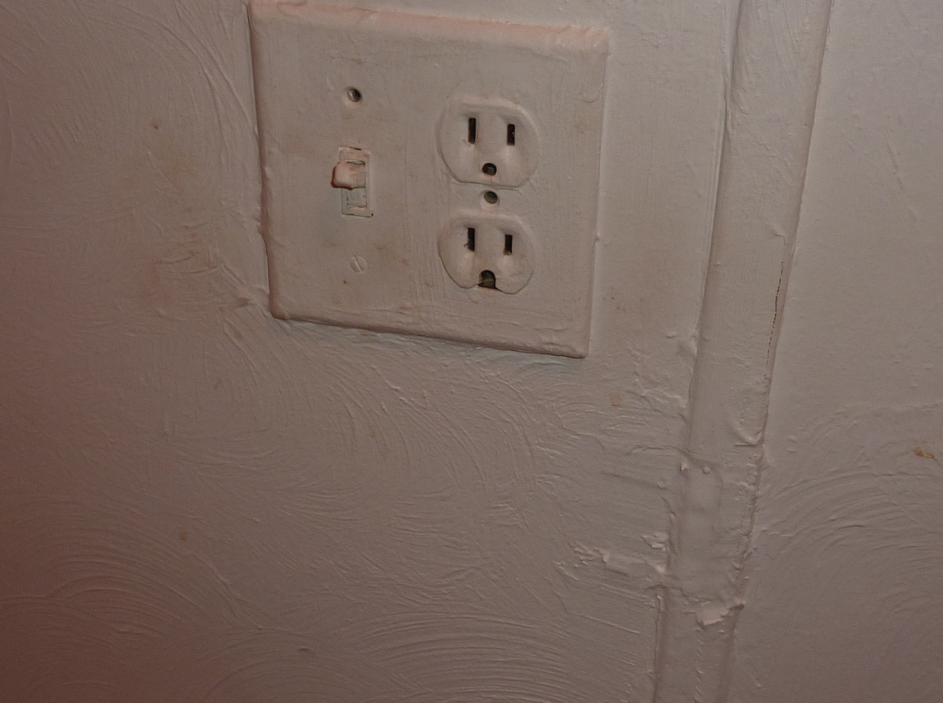

92. More gobbed on filler and paint. This is typical for (BATH2)

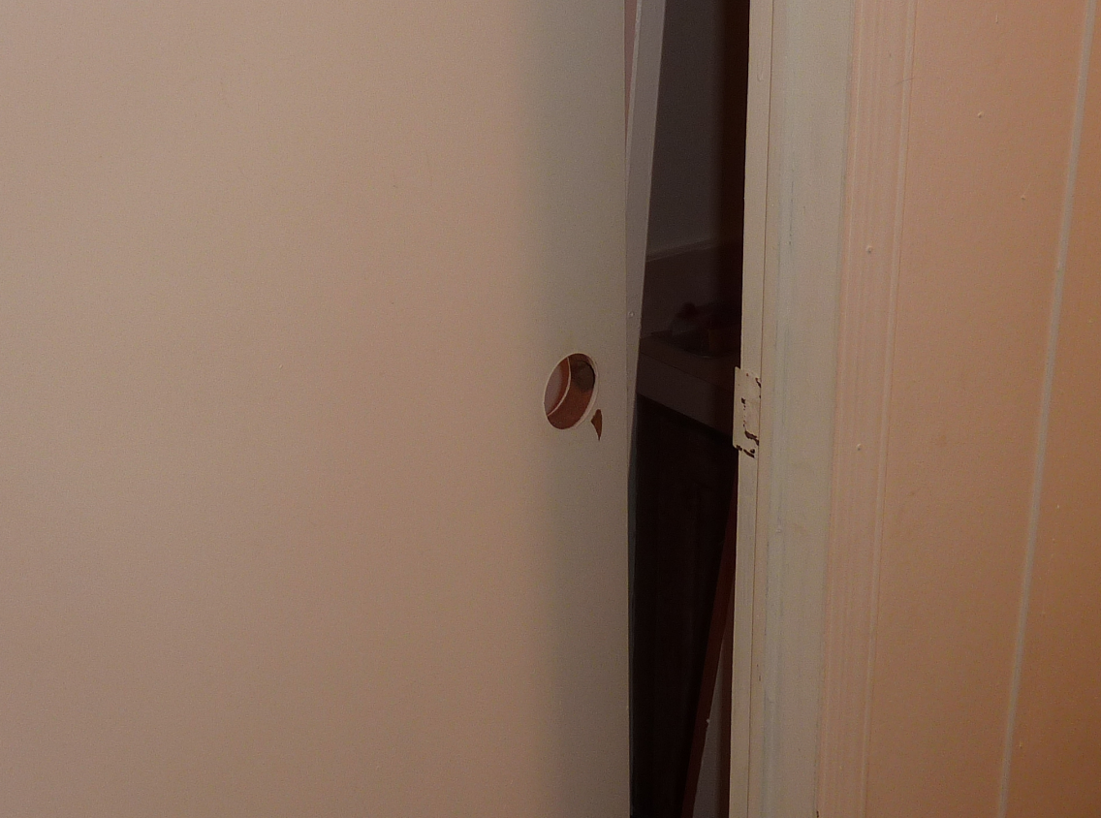

93. Completely missing door handle and strike plate (BATH2)
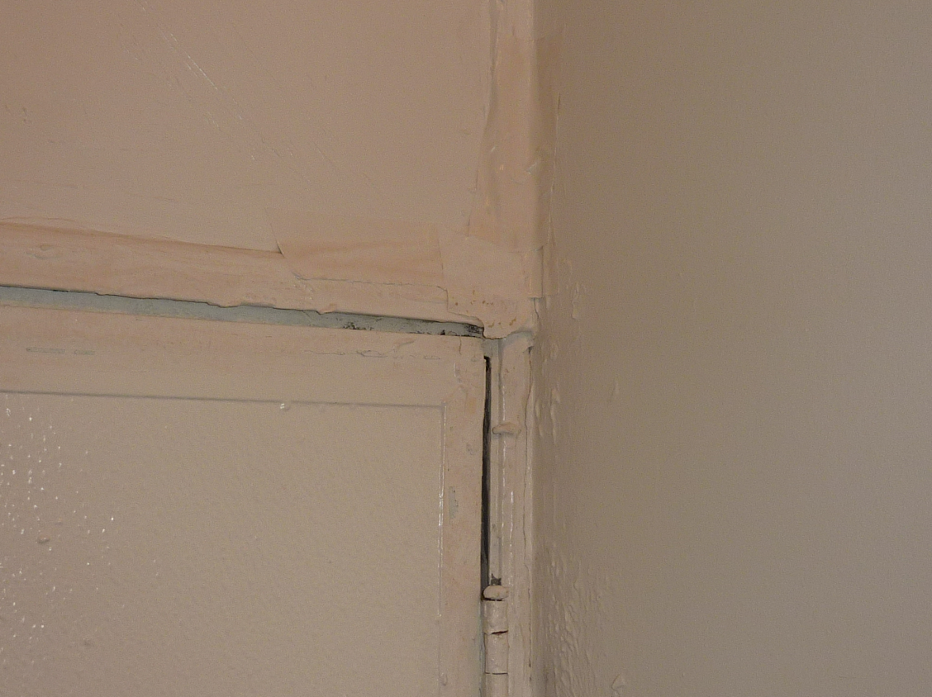

94. Duct taped and painted over door corner. Gobbed on paint and filler. (LAUNDRY)

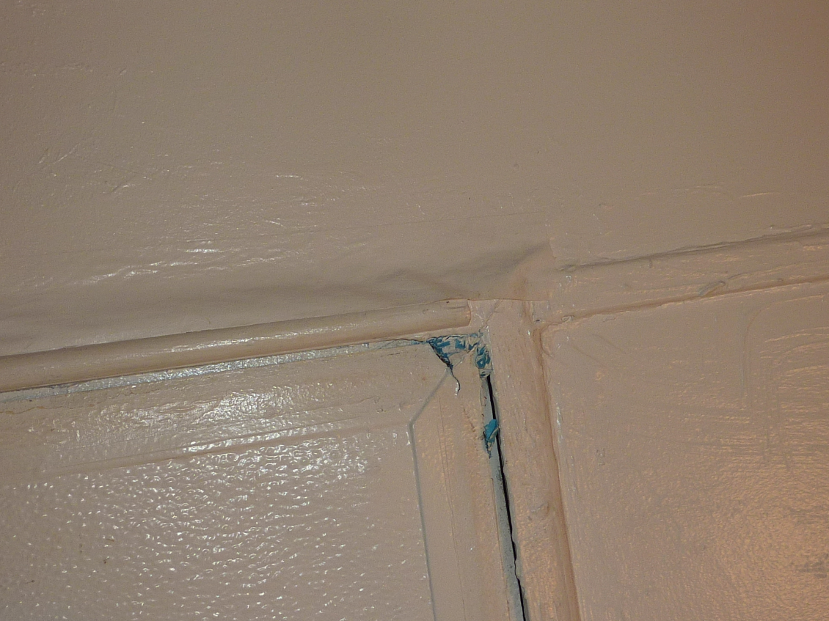

95. Gobbed on paint and filler. (LAUNDRY)

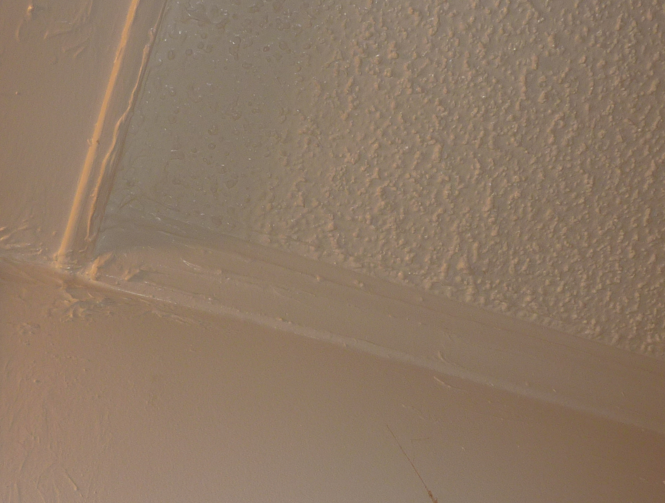

96. More gobbed on paint and filler. (LAUNDRY)

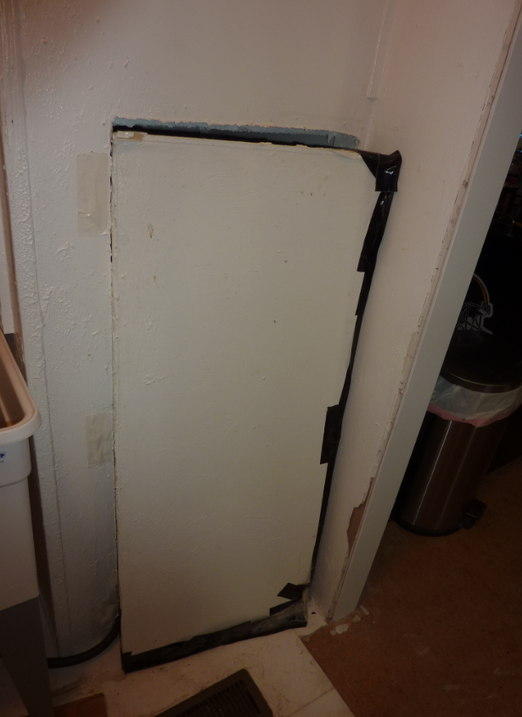

97. Missing door replaced with piece of duct taped fiber board, non attached. (LAUNDRY)

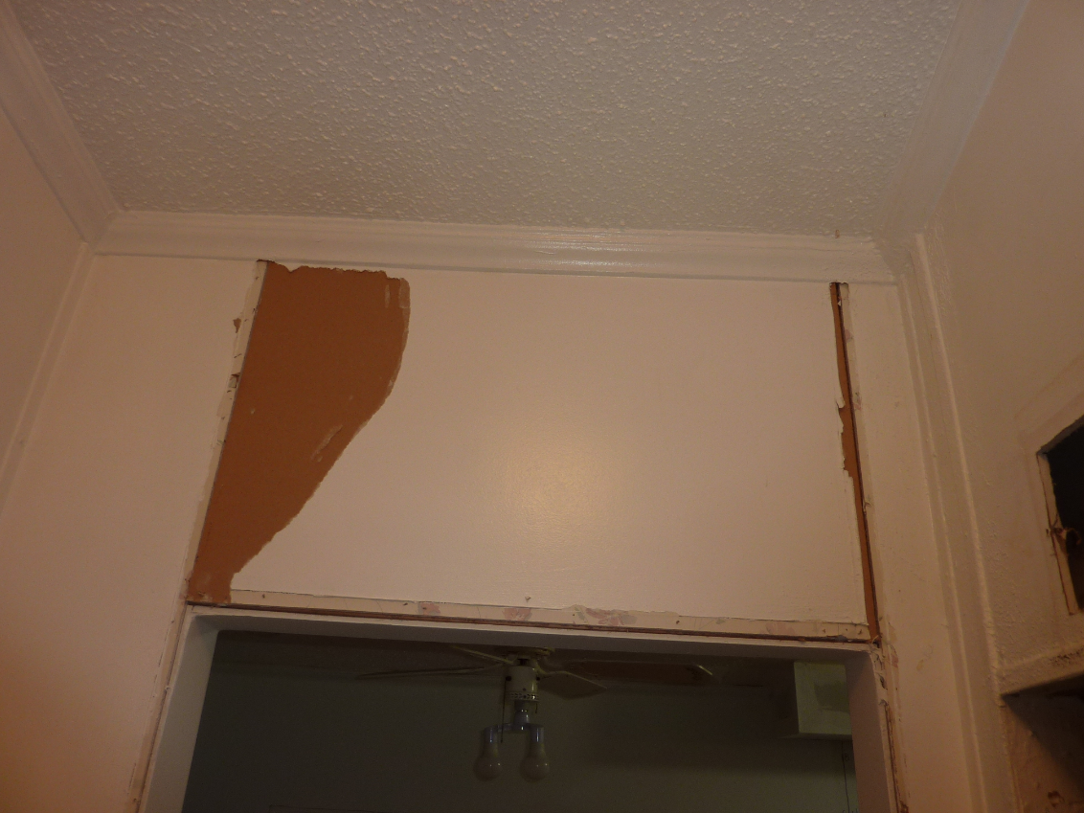

98. Wall damage above laundry entrance.

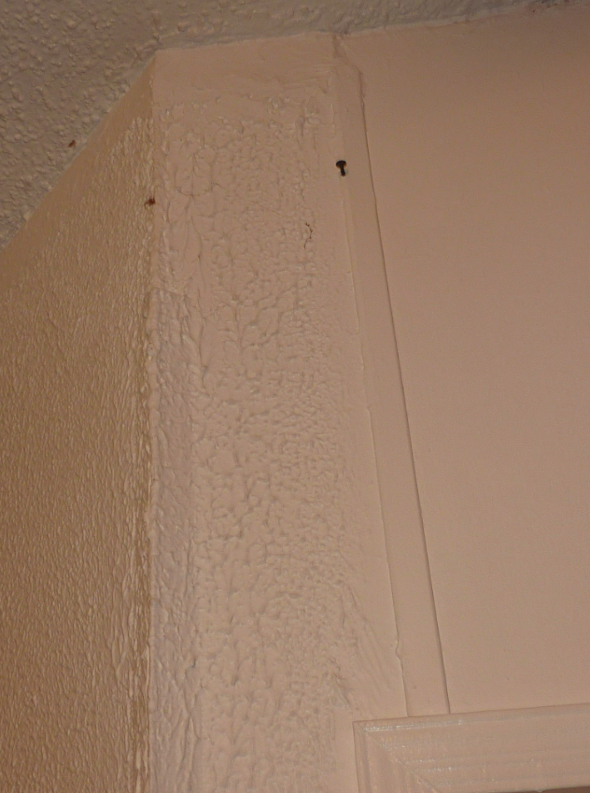

99. Incorrect corner bead installed and is 8” short of ceiling. Poor quality paint finish. (LIVING RM)

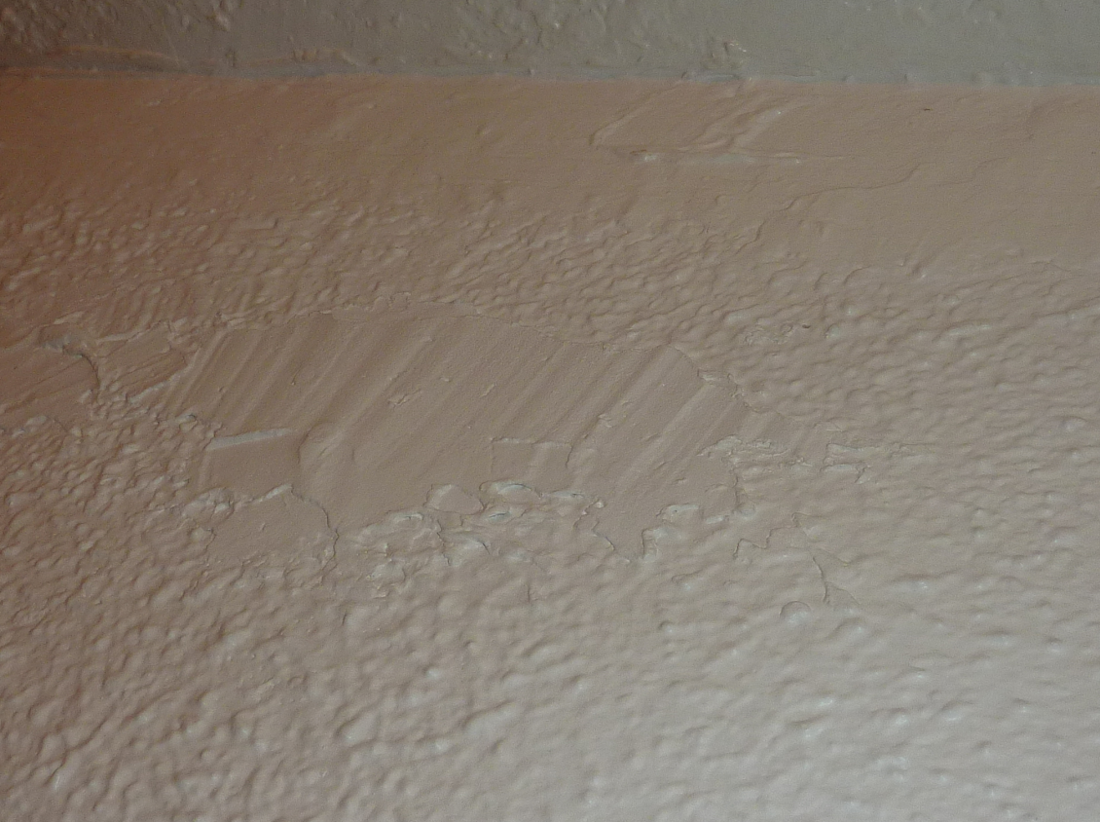

100. Shoddy patch work. (LIVING RM)

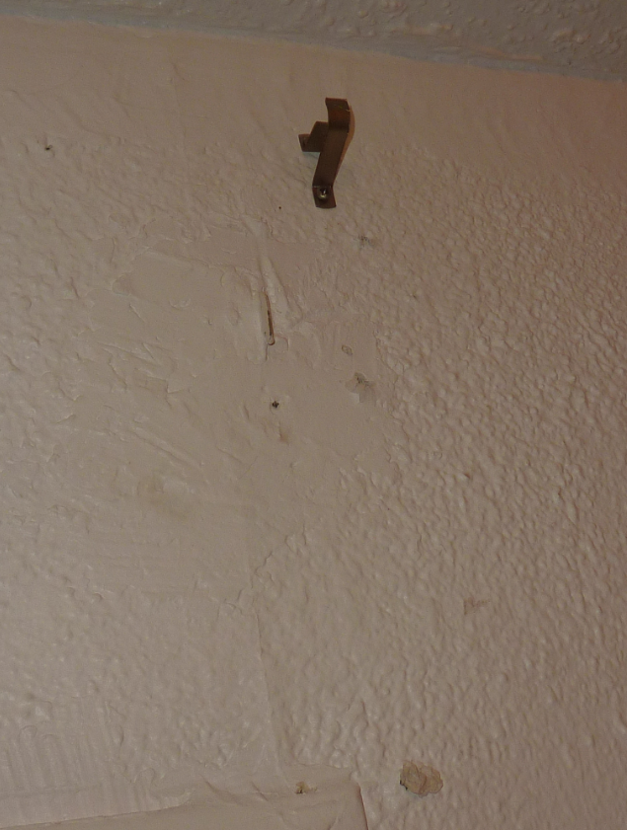

101. More shoddy patch work. (LIVING RM)

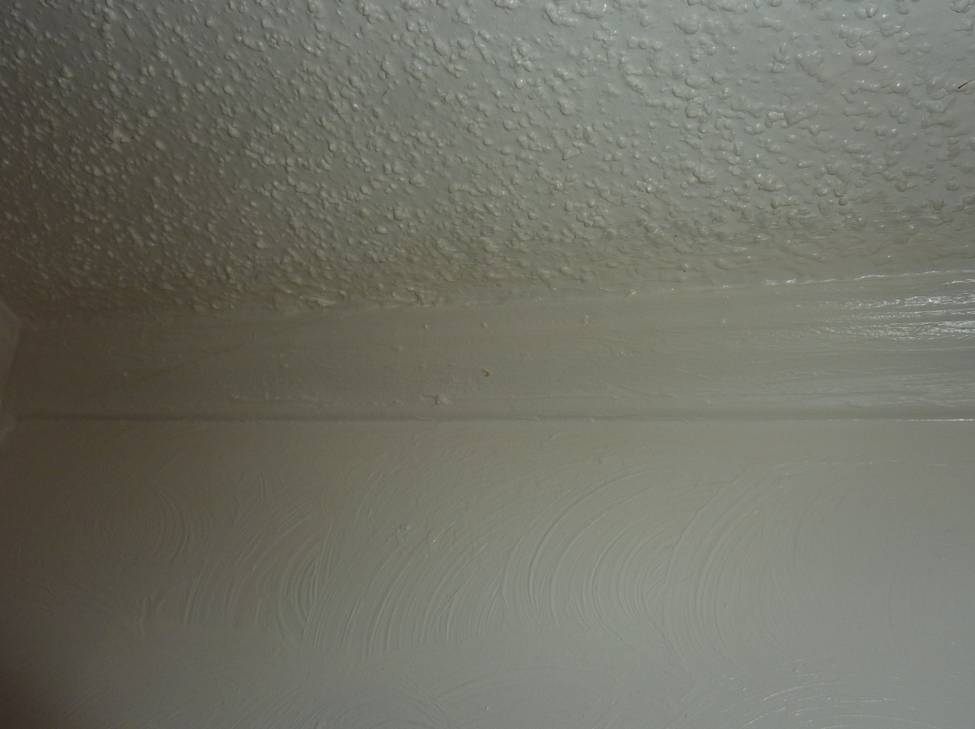

102. Heavy layers of paint. No tape off of ivory wall to white ceiling. Typical all around (LIVING RM)

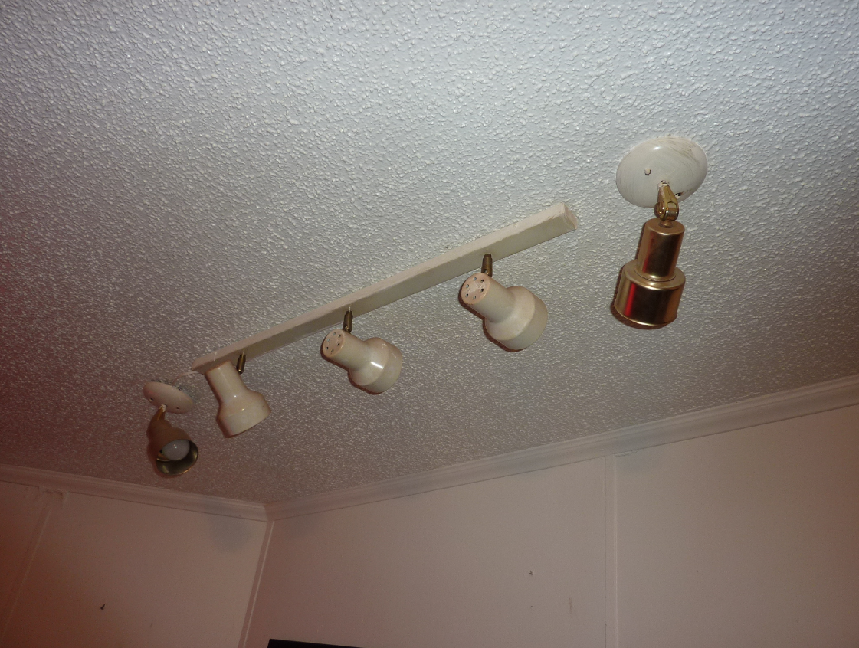

103. Arbitrary light bar install. (LIVING RM)

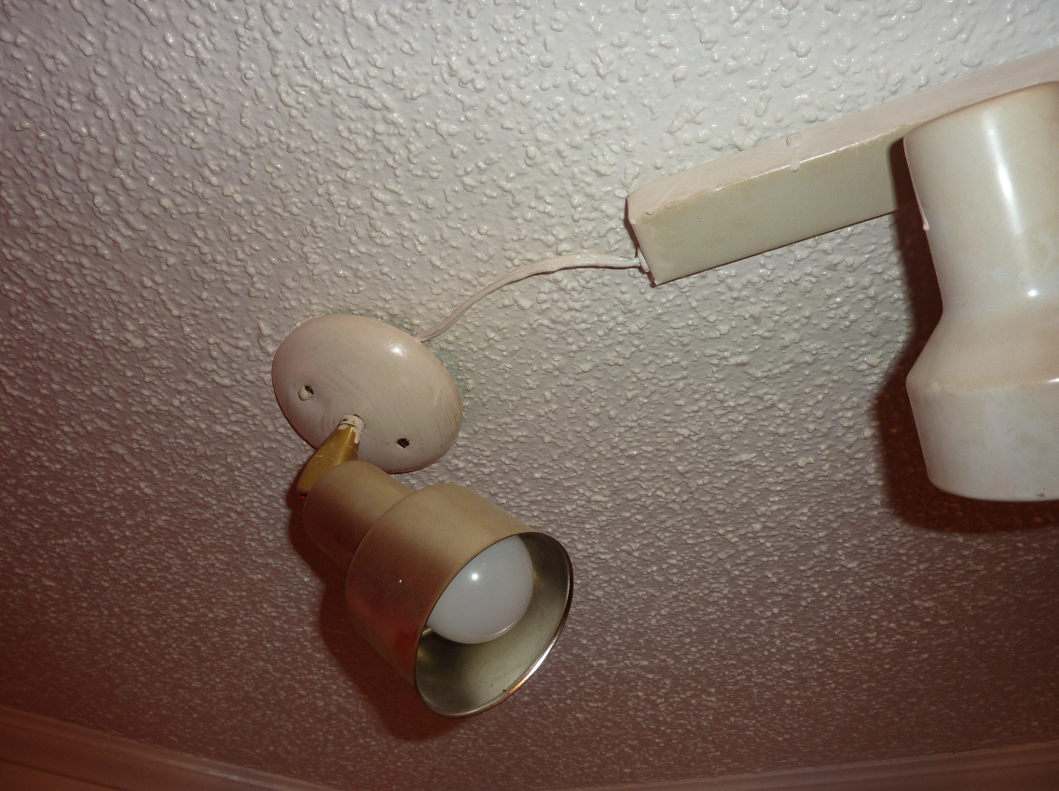

104. End lamp exposed wiring. (LIVING RM)

